Title

Name Surname¹, Name Surname^{2,*}

¹ Department of Important Science; Faculty of Very Important Matters; University of Something; University Street 29, 20-560 City, Country; aaa@aaa.com; ORCID: 0000-0002-1825-0097
² Department of Important Science; Faculty of Very Important Matters; University of Something; University Street 29, 20-560 City, Country aaa@aaa.com; ORCID: 0000-0002-1825-0097
* Corresponding Author

Abstract: Maximum 200 words. The abstract is a concise summary of the entire paper. It is recommended to briefly cover the background, purpose or research question, methods used, key findings, and the conclusions of the study. The abstract must be self-contained, understandable on its own, and include enough information to convey the essence of the research, including its importance. Citations and references to other works are forbidden. Abstracts are indexed in many databases; therefore, well-written abstracts have a greater impact on the scientific community, which can result in increased reader interest and citations.

Keywords: Provide up to seven keywords.

1. Manuscript layout
Please use the simplest possible formatting style and follow the rules given below.
Fonts – use common fonts such as Times New Roman, Calibri, Tahoma, and Arial in size of 10–11 pts.
The title of the work – maximum 20 words. The title should be concise and informative.
Names of authors – full names and surnames of the Authors.
Affiliation – place of employment (Department, Faculty, University), address, e-mail, and ORCID. Provide information for each Author separately. Indicate the corresponding Author.
Abstract – maximum 200 words. The abstract should concisely summarise your research. It should include the main results and the most important conclusions.
Keywords – maximum seven keywords.
Main text – maximum 8000 words.
The preferred layout contains: 1. Introduction, 2. Materials and methods, 3. Results, 4. Discussion, 5. Conclusions,
Acknowledgements – if necessary, provide anyone who helped during your research.
Funding – provide funding sources for the financial support of your research.
References – provide a list of all cited literature at the end of the article.

2. Main text
Sub-sections – if necessary, divide the paper into sub-sections with a brief heading. Number sub-sections as: 1.1., next: 1.1.1., 1.1.2., etc.
Abbreviations – must be explained when they appear for the first time in the text.
Units – use SI units.
Equations – if possible, use MathType or Word equations in editable format. Do not embed equations as images.
Use mathematical standards: symbols (np. sin, ln) – regular font, variables – italic font, vectors, matrices – bold font. Equations should be numbered consecutively.

(1)

Tables – provide tables in editable format, not as images. The tables should be numbered consecutively, and provide their captions and, if necessary, the source: Source: [1]; Source: based on [1].

Table 1. Title. Source: [1]
Heading 1 | Heading 2
Row 1 | Row 1
Row 2 | Row 2
Row 3 | Row 3

Figures – should be numbered consecutively, and provide their captions and, if necessary, the source: Source: [1]; Source: based on [1]. For all types of graphics, use the caption – Fig. All figures must be at least 300 DPI.

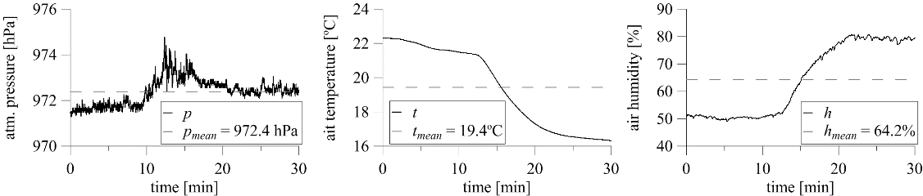
Fig. 1. Title. Source: [1]

References to equations, tables and figures – must be referred to in the text as close as possible to their appearance in the text. The references in text should be as follows: Eq. 1, Tab. 1, Fig. 1 or Eqs 1–2, Tabs 1–2, Figs 1–2.
Literature references – Vancouver System should be used for citations in the text. Cite the literature in the order they are cited in the text, e.g.: [1], [2–5], etc. Mendeley or Zotero is recommended to add references. Please do not cite sources that cannot be verified. For sources in a language other than English, please provide a translation.
Below are examples of references based on the Vancouver style:
Journal paper:
[1] Gołąb J, Borowski Ł. The use of photogrammetry in assessing the stability of escarpment of a ditch draining a forest road. Sylwan. 2025;169(10):703–718. https://doi.org/10.26202/sylwan.2024070
[2] Kardoš M, Borowski Ł, Sackov I, Tomaštík J, Curila D, Maciuk K, et al. Accuracy of forest road digital terrain models captured using airborne and mobile light detection and ranging technology and photogrammetry. Advances in Geodesy and Geoinformation. 2025;74(1):e65. https://doi.org/10.24425/agg.2025.154149
[3] Fusami AA, Edan JD, Takana A. Local orthometric height based on a combination of GPS-derived ellipsoidal height and geoid model: A review paper. Journal of Geodetic Science. Walter de Gruyter GmbH; 2023;13(1):20220158. https://doi.org/10.1515/jogs-2022-0158
[4] Gargula T. Point position accuracy in a vector GNSS network and the way it is linked to reference stations. Geomatics, Land Management and Landscape. 2021;(2):23–37. https://doi.org/10.15576/GLL/2021.2.23
Conference:
[5] Borowski Ł, Banaś M. Application of robust estimation in polynomial modelling. 2018 Baltic Geodetic Congress, BGC-Geomatics 2018. 2018. p. 62–6. https://doi.org/10.1109/BGC-Geomatics.2018.00018
[6] Borowski Ł, Banasik P. The conversion of heights into the PL-EVRF2007-NH frame in Poland. 78th International Scientific Conference of the University of Latvia "Geodynamics and Geospatial Research". University of Latvia; 2022. p. 26. https://doi.org/10.22364/iscul.78.ggr.ba
Book:
[7] Smith Z. Applied gravimetry. AGH University of Science and Technology Publishing House; 2007.
[8] Smith A, Blacksmith T, Nowak A. Geographies of the world. Indiana University Press; 2014.
Book chapter:
[9] Smith PS, Novak A, Grant JM. Chromosome in human solid tumours. In: Borowski B, Lipecki KW, editors. The genetic basis. New York; McGraw-Hill; 2002. p. 93-113

