Paper title in English
Tomasz Adam Kowalski^{a,}*, Dariusz Nowak^{b}
a Department of Computer Science, Lublin University of Technology, Nadbystrzycka 36B, 20-618 Lublin, Poland
b Another Institution, address
Abstract
Lorem ipsum dolor sit amet, consectetuer adipiscing elit. Ut purus elit, vestibulum ut, placerat ac, adipiscing vitae,felis. Curabitur dictum gravida mauris. Nam arcu libero, nonummy eget, consectetuer id, vulputate a, magna. Donec vehicula augue eu neque. Pellentesque habitant morbi tristique senectus et netus et malesuada fames ac turpis egestas. Mauris ut leo. Cras viverra metus rhoncus sem. Pellentesque habitant morbi tristique senectus et netus et malesuada fames ac turpis egestas. Mauris ut leo. Cras viverra metus rhoncus sem.
Keywords: Python; containerisation; Docker
*Corresponding author
Email address: kowalski@company.com (T. A. Kowalski)
Published under Creative Common License (CC BY 4.0 Int.)
- Introduction
This document has been prepared for authors preparing articles in English, with the intention of publication in the Journal of Computer Sciences Institute (J. Comput. Sci. Inst.). The document should be sent electronically via the website: https://ph.pollub.pl/index.php/jcsi.
We submit a document in a two-column format based on a sample template. The file includes a sample document in docx format. The appearance of the created document should be as close as possible to the sample document. This applies absolutely to margins, spacing, font size and style, position and appearance of captions above/below objects. Formulae, figures and other numbered objects should be automatically numbered. Spacing and font should be the same throughout the document. It is imperative that you use the defined styles to change the formatting of your document. The mandatory standard font is Times New Roman, 10 points in size and with single line spacing. The text should be justified with hyphenation turned on. The margins should be: top and bottom 2.5 cm, left and right 2 cm, width of the columns 8 cm with 1 cm space. The first paragraph of each chapter must be without indentation, for this purpose a special style "Normal text no indent" has been added. In the following paragraphs, the style "Normal text with indent" should be used.
After the titles and authors, we present the abstracts in English. They should match each other and should not exceed 800 characters (including spaces). Below we put 3-6 keywords, as in the example, separated by a semicolon. Then we place the content of the document. The paragraphs immediately at the beginning of each chapter are not indented. Other styles are not allowed. We send the final version of the work via the website. Please send the source file to the publishing house in the format:
surname_of_corespondence_author.docx
and a compatible PDF (Portable Document Format) file.
The editors reserve the right to change the final graphic design of the document.
- Formulae
The names of constants and numbers should be written in a simple font, for example 3.1415 hPa. Variable names should be written in italics, and vectors should be additionally bold. Formula numbers should be aligned to the right margin, e.g.:
$$S_{i}=\frac{1}{V_{i}}\left[m_{i}v_{i}⊗v_{i}+\frac{1}{2}\sum_{j≠i}^{N}{r_{i,j}}⊗f_{i,j}\right]$$ | (1)
where m_{i} is the mass of the atom $i$, $v_{i}$ is its velocity, $r_{i,j}= r_{i}-r_{j}$ is a vector connecting two atoms i and j, $V_{i}$ is the volume of the atom i, $f_{i,j}$ is the force of interaction and N is the number of atoms.
- Objects
Figures, tables, examples and algorithms should be placed as close as possible to their first use in the article. Figures, photos, screenshots or graphics in general should be of good quality when included in the content of the article. They should be legible and embedded permanently in the document.
  - Figures
Figures should be centred in relation to the column and captions should be below the drawing, as in Figure 1. It is possible to place a drawing that covers the entire width of the page.
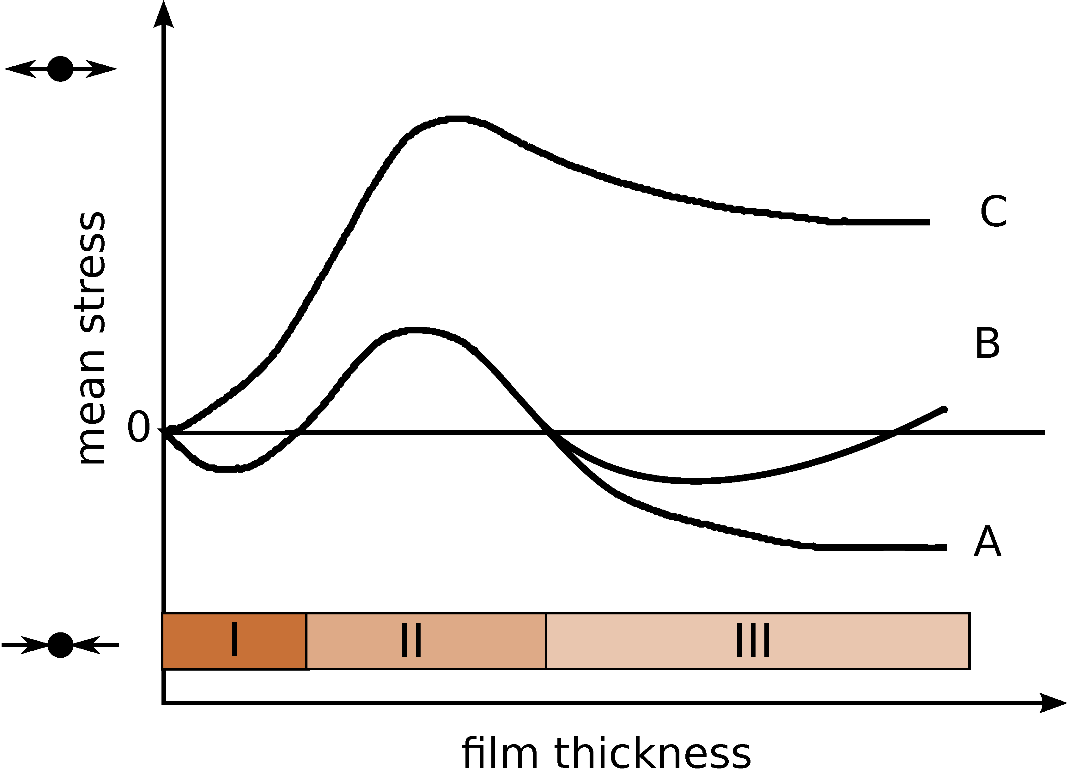
Figure 1: The drawing should be legible and well described
  - Tables
Tables should be numbered and titled above the table as in the example (see Table 1). It is required to use the Table style.
Table 1: Standard deviation of the distance measurement
Model | std.dev. dn(3)  (m) | std.dev. dn(20)  (m) | avarage cpu time  (s)
M1 | 0.0021 | 0.0361 | 0.95
M2 | 0.0020 | 0.0377 | 1.18
M3 | 0.0013 | 0.0190 | 1.38
The size of the font used in the table may be smaller than the font used for the text by a maximum of two points. It is possible to insert a table that covers the entire width of the page.
  - Listings and source codes
Sample program codes should be placed in text form with proper formatting or in the form of good-quality graphics, with proportionality of the font size used (see Listing 1). To improve the readability of the code, you can use fonts other than the base one. Regardless of the method of placement, we sign them at the top, as in the sample code.
Listing 1: Sample program code
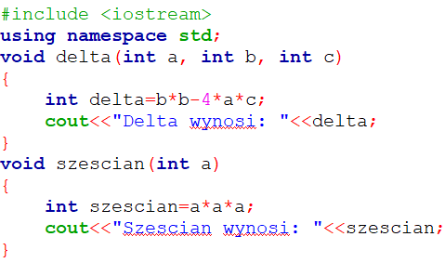
  - Algorithms
A sample Algorithm 1 may look as follows:
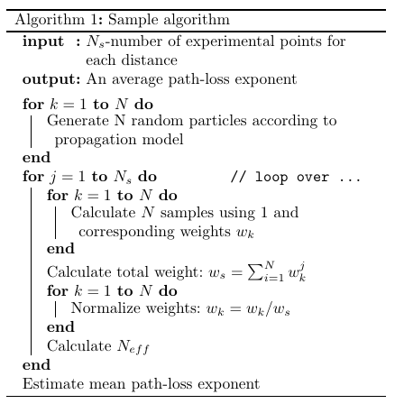
- Ordered and unordered lists
Prepare ordered and unordered lists according to the defined styles. It is allowed to change the list numbering style.
An example of an ordered list:
- Lorem ipsum dolor sit amet, consectetuer adipiscingelit Ut purus elit, vestibulum ut, placerat ac, adipiscing vitae, felis.
  - Curabitur dictum gravida mauris. Nam arcu libero, nonummy eget, consectetuer id, lputatea, magna:
    - Duis aute irure dolor in reprehenderit in voluptate velit esse cillum dolore.
    - Fugiat nulla pariatur. Excepteur sint occaecat cupidatat non proident, sunt in culpa qui officia deserunt mollit anim id est laborum.
  - Lorem ipsum dolor sit amet, consectetuer.
- Lorem ipsum dolor sit amet, consectetuer adipiscingelit Ut purus elit, vestibulum ut, placerat ac, adipiscing vitae, felis.
- Lorem ipsum dolor sit amet, consectetuer adipiscingelit Ut purus elit, vestibulum ut, placerat ac, adipiscing vitae, felis.
An example of an unordered list:
- lorem ipsum dolor sit amet, consectetuer adipiscingelit Ut purus elit,
- lorem ipsum dolor sit amet, consectetuer adipiscingelit Ut purus elit:
  - lorem ipsum dolor sit amet, consectetuer adipiscingelit Ut purus elit,
  - lorem ipsum dolor sit amet, consectetuer adipiscingelit Ut purus elit,
- lorem ipsum dolor sit amet, consectetuer adipiscingelit Ut purus elit.
- Conclusions
Conclusions should contain a short summary of the most interesting results contained in the work. In addition, you may provide information on the conduct of research under a funded research programme, acknowledgements of companies/people cooperating in the research, as well as the consent of the Research Ethics Committee when experiments involving human participants were carried out in the research.
References
Items in the reference list [1-3] should be numbered in square brackets in the order in which they appear in the article. The References section name should not be numbered. Subsequent references should be placed as in the given example. We prefer descriptions of literature in English (items in the literature list). Instead of specifying the page range in a bibliographic entry, the article identifier can be used [4]. References to the website [6] in the reference list and to DOI addresses should be active and placed as in the example [9, 10].

References
- G. Dziewit, J. Korczyński, M. Skublewska-Paszkowska, Performance analysis of relational databases Oracle and MS SQL based on desktop application, Journal of Computer Sciences Institute 8 (2018) 263–269, https://doi.org/10.35784/jcsi.693.
- W. Bolesta, Analysis of query execution speed in the selected NoSQL databases, J. Comput. Sci. Inst. 7 (2018) 138–141, https://doi.org/10.35784/jcsi.662.
- D. V. Nesterenko, Surface plasmon sensing with different metals in single and double layer configurations, Appl. Opt. 51(27) (2012) 6673–6682, https://doi.org/10.1364/AO.51.006673.
- A. Sutton, L. Tompson, Towards a cybersecurity culture-behaviour framework: A rapid evidence review, Computers & Security 148 (2025) 104110, https://doi.org/10.1016/j.cose.2024.104110.
- T. Zientarski, D. Chocyk, Structure and stress in Cu/Au and Fe/Au systems: A molecular dynamics study, Thin Solid Films 562 (2014) 347–352.
- Insert a short description of the link. TEX–basics, https://en.wikibooks.org/wiki/LaTeX/Plain_TeX, [12.01.2025].
- P. G. de Gennes, Scaling Concepts in Polymer Physics, Cornell University Press, London, 1979.
- S. Ambler, User Interface Design: Tips and Techniques, Cambridge University Press, Toronto, 2000.
- E. Casalicchio, V. Percibali, Measuring Docker Performance: What a mess!!!, Proceedings of the 8th ACM/SPEC on International Conference on Performance Engineering Companion (2017) 11–16, https://doi.org/10.1145/3053600.3053605.
- J. Stubbs, W. Moreira, R. Dooley, Distributed systems of microservices using Docker and Serfnode, In 7th International Workshop on Science Gateways (2015) 34–39, https://doi.org/10.1109/iwsg.2015.16.
- M. Gajewski, W. Zabierowski, Analysis and comparison of the Spring framework and play framework performance, used to create web applications in Java, In IEEE XVth International Conference on the Perspective Technologies and Methods in MEMS Design (2019) 170–173.
- S. Pavkov, I. Franković, N. Hoić-Božić, Comparison of game engines for serious games, In 2017 40th International Convention on Information and Communication Technology, Electronics and Microelectronics (MIPRO) IEEE (2017) 728–733.
- N. Ndou, R. Ajoodha, A. Jadhav, Music genre classification: A review of deep-learning and traditional machine learning approaches, In 2021 IEEE International IOT, Electronics and Mechatronics Conference (IEMTRON-ICS) (2021) 1–6.
- J. Jagiełło, Performance comparison between React Native and Flutter, Bachelor thesis, Umeå University, Umeå, 2019.
- M. Jusięga, Comparative analysis of selected versions of the Symfony programming framework, Master thesis, Lublin University of Technology, Lublin, 2020.
- R. Torkar, Towards Automated Software Testing: Techniques, Classifications and Frameworks, PhD dissertation, Blekinge Institute of Technology, 2006.
- K. Islam, Recent Advances in Vision Transformer: A Survey and Outlook of Recent Work, arXiv preprint arXiv:2203.01536 (2023), https://doi.org/10.48550/arXiv.2203.01536.
- P. Giannopoulos, I. Perikos, I. Hatzilygeroudis, Deep Learning Approaches for Facial Emotion Recognition: A Case Study on FER-2013, In: I. Hatzilygeroudis, V. Palade, (eds) Advances in Hybridization of Intelligent Methods. Smart Innovation, Systems and Technologies,
Springer 85 (2018) 1-16, https://doi.org/10.1007/978-3-319-66790-4_1.

