PROBLEMY EKOROZWOJU/ PROBLEMS OF SUSTAINABLE DEVELOPMENT
SUBMITTED: 18.03.2024, ACCEPTED: 18.04.2024, PUBLISHED ON-LINE: 1.07.2024
2024, 19(2): 293-308
DOI: https://doi.org/10.35784/preko.6015

The Transformation of the European Union’s Energy Sector

Transformacja sektora energetycznego Unii Europejskiej

Dmytro Banas¹, Tetiana Melnyk²

¹State University of Trade and Economics
02156, 19, Kyoto street, Kyiv, Ukraine
E-mail (Corresponding Author): dmytro_banas@sci-univ.com
²Kyiv National University of Trade and Economics
Department of International Management
02156, 19 Kyoto Str., Kyiv, Ukraine

Abstract
Such geoeconomic and geopolitical factors as Russian armed aggression against Ukraine caused the energy crisis in the European Union (EU), exposing the EU’s vulnerabilities due to its overdependence on Russian fossil fuel imports. As a consequence of gas supply disruptions, substantial rises in energy prices and heightened safety concerns, the EU's energy policies have been thoroughly reassessed. Therefore, the article aims to examine the profound ramifications of Russia's military aggression against Ukraine on European energy markets and elucidate the strategies articulated in European Commission initiatives intended to reduce reliance on Russian fossil fuels. Within this framework, the REPowerEU plan is especially beneficial for the rapid diversification and increased integration of renewable energy sources. These initiatives have the potential to result in a structural transformation of the EU's energy landscape, necessitating coordinated regulatory initiatives, infrastructure advancements, and cooperative energy diplomacy. Current research reveals the potential for economic expansion, strengthened industrial primacy and progress towards achieving climate neutrality by 2050 through the environmentally sustainable metamorphosis of Europe's energy framework. The results of this scientific research can also be used for the further implementation of the strategy of achieving sustainable development of the EU member states in the context of the development of clean energy, which will allow meeting the needs of the population of these countries in the near future without endangering future generations.

Key words: energy crisis, geoeconomics, reliance on Russian energy, Russian fossil fuels, REPowerEU plan, renewable energy transformation, transition to clean energy, sustainable development, carbon neutrality

Streszczenie
Takie czynniki geoekonomiczne i geopolityczne, jak rosyjska agresja zbrojna na Ukrainę, spowodowały kryzys energetyczny w Unii Europejskiej (UE), obnażając słabość UE wynikającą z jej nadmiernej zależności od importu rosyjskich paliw kopalnych. W wyniku zakłóceń w dostawach gazu, znacznych podwyżek cen energii i zwiększonych obaw dotyczących bezpieczeństwa polityka energetyczna UE została ponownie dokładnie oceniona. Celem artykułu jest zatem zbadanie głębokich konsekwencji agresji militarnej Rosji przeciwko Ukrainie na europejskich rynkach energii oraz wyjaśnienie strategii sformułowanych w inicjatywach Komisji Europejskiej mających na celu zmniejszenie uzależnienia od rosyjskich paliw kopalnych. W tych ramach plan REPowerEU jest szczególnie korzystny dla szybkiej dywersyfikacji i zwiększonej integracji odnawialnych źródeł energii. Inicjatywy te mogą potencjalnie skutkować strukturalną transformacją krajobrazu energetycznego UE, co wymaga skoordynowanych inicjatyw regulacyjnych, rozwoju infrastruktury i wspólnej dyplomacji energetycznej. Obecne badania ukazują potencjał ekspansji gospodarczej, wzmocnienie prymat przemysłu i postęp w kierunku osiągnięcia neutralności klimatycznej do 2050 r. poprzez zrównoważoną środowiskowo metamorfozę europejskich ram energetycznych. Wyniki tych badań naukowych mogą także zostać wykorzystane do dalszej realizacji strategii zrównoważonego rozwoju państw członkowskich UE w kontekście rozwoju czystej energii, co pozwoli zaspokoić potrzeby ludności tych krajów w najbliższej przyszłości, bez narażania przyszłych pokoleń.
Słowa kluczowe: kryzys energetyczny, geoekonomia, zależność od rosyjskiej energii, rosyjskie paliwa kopalne, plan REPowerEU, transformacja energetyki odnawialnej, przejście na czystą energię, zrównoważony rozwój, neutralność węglowa

Introduction

As a key component of the institutional system of European integration and the functioning of the European Union’s (EU’s) economy, the energy market is among the first to respond to contemporary global, technological, economic, social, and environmental challenges. The threat of global warming and critical environmental pollution has dominated the worldwide agenda in the past years, prompting European countries’ policies to focus on creating mechanisms for transition to low-carbon energy and increasing energy efficiency through the technology and economization of alternative energy sources. The fight for carbon-neutral energy has become one of the main directions of the EU government's activities, which is also reflected in the sustainable development goals that were formed by the UN. As a consequence of various geoeconomics and geopolitical factors, particularly armed conflicts, the issues of Europe's energy security are now at the forefront.
Since the beginning of the Russian unjustified armed aggression against Ukraine, the global energy system has been exposed to numerous threats and experienced substantial disruptions. Energy prices keep on increasing, and energy security causes concerns, indicating the EU’s overdependence on gas, oil, and coal imports from the Russian Federation. Europe's energy system is in the grip of an unprecedented crisis. Russian gas supply, which was critical for heating buildings, industrial processes, and electricity generation, was reduced by more than 80% in 2022. Since the beginning of 2021, wholesale prices for electricity and gas have increased 15 times, with significant consequences for households and businesses.
The main reason for the significant increase in European petrol prices is a reduction in Russian supplies. The primary alternative is liquefied natural gas (LNG). Following Russia's invasion of Ukraine in February, the cost of LNG more than doubled. The increase in wholesale electricity prices is attributed to the rise in natural gas prices and insufficient nuclear and hydroelectric power production, which had to be supplemented with electricity from more expensive coal and gas power plants.
As a result, there is currently an objective need for all market participants to adapt to the new realities of its functioning, especially considering European economies' desire to reduce their reliance on imported fuel. Thus, Russia's invasion of Ukraine serves as a stark reminder of the consequences such dependence on imports of fossil fuels from third countries can have on European energy markets and supply security.
According to the European Commission's plans, it is intended to significantly reduce reliance on Russian fossil fuels and accelerate the energy transition, with the help of the following strategies:
- energy efficiency measures (reducing natural gas consumption by 30% by 2030);
- energy supply diversification;
- rapid substitution of fossil fuels with clean energy sources (increasing the share of renewable sources to 45% in the EU's energy balance by 2030);
- careful combination of investments and reforms (European Commission, 2022a).
The above measures can restructure the EU's energy system if the EU takes effective actions regarding the regulation and coordination of infrastructure. Furthermore, national investments, reforms, and collaborative energy diplomacy are also necessary. It is crucial to depress the demand for coal, oil, and gas by consuming less energy and shifting the industry to fossil-fuel-free renewable electricity and hydrogen. On the supply side, the EU should drive up the deployment and production of renewable energy by developing the capacity and structures of the latter. Therefore, this article focuses on the current challenges in reshaping Europe's energy markets, with an emphasis on issues exacerbated by contemporary concerns regarding the war.
During the research, insights from the studies of various Ukrainian scholars, such as Bila (2018), Wołowiec et al. (2022), Perevozova et al. (2022), Turchyn and Ivasechko (2020), and others who explored theoretical foundations and applied issues related to the energy markets developing in Europe and the EU, were considered. Numerous non-Ukrainian scholars, including Ghilès (2022), Terazono et al. (2022), Terzian (2022), and Blanc (2022), who have addressed the challenges of contemporary European energy market transformation in the context of the war with Russia, also were taken into consideration.
The majority of existing academic literature on European-Russian energy relations emphasises the analysis of European energy policies and strategies, as well as the risks and threats that European countries face due to their reliance on Russian natural gas. This suggests that a substantial body of literature exists, focusing primarily on European supply security strategies (for example, Silva, 2007; Constantini et al., 2007; Rodrigues et al., 2014). However, a more in-depth examination of theoretical and scientific-practical aspects related to the uniqueness of EU energy markets and the transformation processes as a response to market challenges posed by Russia's aggression in Ukraine is required.

1. Measures to reduce reliance on Russian energy

During 2021, the European Commission addressed the issue of rising energy prices. Following Russia's invasion of Ukraine and subsequent use of energy resources for blackmail against Europe, the situation in the energy market significantly worsened. Russia continues to manipulate gas supplies, halting deliveries to Europe for unreasonable motives, and markets are becoming more challenging and volatile. Despite a significant reduction in Russian energy resources supply – from 45% of gas imports in 2021 to 14% in September 2022, – Europe managed to find alternative energy sources and to compensate for the shortage by lowering demand. Additionally, political measures were taken to limit overall market volatility and redirect excess revenues from the energy sector to benefit citizens and businesses.
The chronology of the EU’s decision-making to address the challenges posed by the Russian armed aggression against Ukraine is outlined in Table 1.

Table 1. European Union decisions on energy, Source: compiled by the author based on: Energy. EU Policies Aim to Deliver Secure, Sustainable, and Affordable Energy for Citizens and Businesses (2023)
Date | Measure
October 13, 2021 | Message: Tackling rising energy prices: A toolbox for action and support
March 8, 2022 | Concept: REPowerEU: Joint European action for more affordable, secure and sustainable energy
March 23, 2022 | Communication from the Commission to the European Parliament, the European Council, the Council, the European Economic and Social Committee and the Committee of the Regions Security of supply and affordable energy prices: Options for immediate measures and preparing for next winter
May 18, 2022 | European Commission REPowerEU: A plan to rapidly reduce dependence on Russian fossil fuels and fast forward the green transition
April 21, 2022 | IEA company and EC Playing my Part with tips on energy conservation to help reduce the EU's dependency on Russian fuels
June 27, 2022 | Adoption of the Gas Storage Regulation (EU 2022/1032)
July 20, 2022 | Commission proposal for council regulation on coordinated demand reduction measures for gas and the communication Save gas for a safe winter
July 26, 2022 | Energy Ministers agreement on the Regulation on coordinated demand reduction measures for gas
September 14, 2022 | Proposal for a Council regulation on an emergency intervention to address high energy prices and reduce electricity bills for EU citizens
September 30, 2022 | Energy Ministers' Agreement on the Regulation on an emergency intervention to address high energy prices and reduce electricity bills for EU citizens
October 18, 2022 | Additional proposals from the Commission to fight high energy prices and ensure security of supply

At the time of Russia's full-scale invasion of Ukraine, the primary focus was on the development and transformation of Europe's energy system, with a particular emphasis on reducing the negative environmental impact. To ensure the success of the transformation, the EU planned to implement a number of measures, including ambitious levels of EU funding in addition to member countries' resources to support innovations in clean energy technologies; ensuring fairness and transparency in distributing the financial burden of energy transformation; ensuring a well-functioning, non-distorted, and integrated internal energy market; ensuring a more strategic, unified and reliable energy security policy, coupled with EU global leadership in multilateral cooperation in energy transformation. However, a geopolitical conflict arose, specifically Russia's unprovoked and unjustified military aggression against Ukraine, which caused significant disruptions in the global energy system. This resulted in challenges due to high energy resource prices and increased concerns about energy security, bringing the EU's excessive reliance on Russia's import of gas, oil, and coal to the forefront. The substantial financial outlays for Russian fossil fuels contribute to sustaining Russia's ongoing war against Ukraine.
At the European Council in March 2022, European Union leaders agreed to reduce Europe's reliance on Russian energy imports as soon as possible (European Council Conclusions, 2022). The REPowerEU plan was at the heart of this initiative, intending to rapidly decrease our reliance on Russian fossil fuels by swiftly transitioning to a clean energy shift and pooling efforts to achieve a more resilient energy system and a genuine Energy Union.
Industry representatives accepted the European Commission's Communication on REPowerEU (2022) on the expedited development of a detailed REPowerEU plan. This comes as the import of coal and oil falls under sanction regimes. Disruptions in gas supply to Bulgaria and Poland have demonstrated the urgent importance of addressing the issue of Russian energy supply dependability.
The REPowerEU strategy focuses on reducing the EU's reliance on Russian fossil fuels as quickly as possible through a rapid transition to clean energy and consolidating efforts to achieve a more sustainable energy system and a genuine Energy Union. Building on the Fit for 55 package proposals and concluding actions on supply security and storage, the REPowerEU plan offered a new set of measures (Figure 1) aimed at:
- energy efficiency;
- supplies diversification;
- rapid replacement of fossil fuels by hastening Europe's transition to clean energy;
- an intelligent combination of investments and reforms.

REPowerEU
the gradual reduction in reliance on Russian fossil fuels
SMART-investments
Ukrainian and European plans: Reforms and investments, accelerated permitting, and innovations
Rapid transition to clean energy
Energy savings
Diversification of fuel supply sources
Figure 1. EU energy system transformation strategy, source: European Commission (2022a)

The above measures can restructure the EU's energy system if the EU takes effective actions regarding the regulation and coordination of infrastructure. Furthermore, national investments, reforms, and collaborative energy diplomacy are also necessary. It is crucial to depress the demand for coal, oil, and gas by consuming less energy and shifting the industry to fossil-fuel-free renewable electricity and hydrogen. On the supply side, the EU should drive up the deployment and production of renewable energy by developing the capacity and structures of the latter.
Energy efficiency is the most cost-effective and time-efficient method to come out of the existing energy crisis. It is possible to reduce fossil fuel imports from Russia if energy consumption is reduced while saving electricity bill money for households and businesses. A decrease in energy consumption is an essential step toward a clean energy shift; it strengthens the economic resilience and competitiveness of the EU under the conditions of high fossil fuel prices.
Energy savings allowed for a stable supply during the critical months following investment deployment. According to the two-pronged approach presented in the EU message on Energy Conservation, it is advisable to promote changes in the energy structure and consumption behaviour by taking medium- and long-term measures to enhance energy efficiency.
Fit for 55 envisions a 30% reduction in petrol consumption by 2030. More than one-third of this reduction is expected to come from the EU's energy efficiency targets. The impact of the gradual reduction in the EU's dependence on Russian fossil fuels is noticeable since energy prices are higher and natural gas consumption decreases (REPowerEU scenario, 2022). The provisions of the Energy Efficiency Directive (COM, 2021) provide for further reductions in energy consumption, and REPowerEU sets tougher renewable energy objectives for the EU. As for any other aspect, Fit for 55 is left as it is.
In addition, the Commission suggests the Energy Performance of Buildings Directive be amended to achieve additional energy savings and improve energy efficiency in buildings. It also encourages support for the Commission's ambitious proposal on the Eco-design Regulation for environmentally friendly products (COM, 2022). The regulation aims to increase energy and resource efficiency across a wide range of products, resulting in additional energy savings. The plan indicates that changing behaviour can result in immediate energy savings before legislative measures are agreed upon. The European Commission and the International Energy Agency (IEA) (2022) introduced a joint plan to decrease energy consumption in the EU. The plan titled Playing My Part can help to depress the demand for petrol and oil by up to 5% (approximately 13 billion cubic metres and 16 million tonnes, respectively).
Given that some EU member countries are more vulnerable to the influence of Russian gas than others, potential disruptions would affect everyone collectively. Therefore, EU policy aims for all member countries to stand united, ready to share gas with their neighbours in times of need. Thus, as a result of the consolidated policy, all EU countries agreed to reduce petrol consumption by a minimum of 15%; from August 2022 to March 2023, petrol demand fell by 18%, exceeding the target; according to the Commission's proposal, member countries extended the voluntary goal of reducing petrol demand for another year in March 2023.

1.1. Energy import diversification
The EU has been intensively cooperating with international partners over the last few months; this cooperation is aimed at expanding supplies and mitigating the effects of rising energy prices (EU-US LNG TRADE, 2022). The EU Energy Platform was established by the Commission and member countries in accordance with the mandate of the European Council in March. The platform is for voluntary joint procurement of gas, liquefied natural gas, and hydrogen. On May 5, the Commission and Bulgaria established the first regional working group within the EU Energy Procurement Platform, coordinating with southeastern European neighbours. Its primary functions include the following:
- structuring and grouping demands: the disputed volumes will be determined and grouped by demands depending on terminating period contracts and flexible volumes under ongoing period gas contracts. This makes it possible to provide 30-70 billion cubic metres of demand in the short term. Furthermore, the Commission has taken the necessary legislative steps to facilitate diversification. Electronic tools support demand aggregation, making the process secure, automated, and user-friendly;
- ensuring facilitated and transparent utilization, storage, and transportation of imported gas, providing maximum supply safety and reservoir replenishment. This entails creating mechanisms and IT tools to enhance the infrastructure booking transparency, such as secondary markets, bottlenecks, availability, and route changes. Antimonopoly rules govern information exchange;
- international coverage: a consolidated global approach focuses on establishing long-term framework deals of cooperation with dependable partners through binding or non-binding commitments to support gas and hydrogen procurement and the development of clean energy projects, fully leveraging the EU's collective strength.
As a result of the European Commission's measures, Russian gas accounted for only 8% of total pipeline gas imported into the EU in September 2022, compared to 41% of EU imports from Russia in August 2021 (Figure 2).
In this way, the successful diversification of energy supply under the REPowerEU plan was mainly achieved by:
- reaching pipeline import agreements with other third countries;
- investing in liquefied natural gas (LNG) joint procurement;
- forming strategic alliances with Namibia, Egypt, and Kazakhstan to ensure a secure and long-term supply of renewable hydrogen;
- signing agreements with Egypt and Israel for natural gas exports to Europe.
The EU should protect not only its energy supply for the upcoming winter but also for the coming years. That is why this type of collaboration focuses on achieving climate neutrality by creating a more environmentally sustainable future.
Member countries that rely on Russia for nuclear fuel for their reactors, whether they serve electricity production or non-energy use, require diversification options. Currently, five member countries (Bulgaria, the Czech Republic, Finland, Hungary, and Slovakia) utilize VVER reactors that are fully dependent on fuel supplied by a Russian provider. Additionally, Medium Power Research Reactors (MPRR), including reactors in the Czech Republic, Hungary, and Poland, have an original Soviet design are fuelled by a monopolistic Russian manufacturer. In order to achieve this, the EU and international partners should strengthen their cooperation in securing alternative uranium sources. Moreover, fuel conversion, enrichment, and manufacturing should be enhanced in Europe or through global EU partners. The search for external suppliers should be supplemented by producing domestic natural gas for member countries; all these actions can contribute to strengthening supply security.

Figure 2. Changes in the structure of EU gas supplies, source: compiled by the authors based on the REPowerEU. Affordable, Secure and Sustainable Energy for Europe (2022)

1.2. Replacing fossil fuels and hastening Europe's transition to clean energy
Substantially accelerating and expanding renewable energy in the energy sector, industry, construction, and transportation will accelerate the gradual phase-out of Russian fossil fuels. This is expected to lower electricity prices over time and reduce the import of fossil fuels (European Commission, 2022a).
The following are the renewable energy development directions outlined in the REPowerEU Plan dated May 18, 2022:
- based on impact modelling and implementation feasibility, the Commission has proposed increasing the objective within the Renewable Energy Directive to 45% by 2030 from the previous 40%. This improvement will increase renewable energy capacity to 1236 GW by 2030, up from the 1067 GW previously projected in Fit for 55;
- the solar photovoltaic system is one of the most rapidly employed technologies. Therefore, the Commission has set the REPowerEU goal of doubling the current level of solar photovoltaic installations by 2025 to over 320 GW and reaching 600 GW by 2030. The European Commission presented the EU Solar Strategy (European Commission, 2023a) and introduced the European Solar Rooftop Initiative. The initiative is built on obligatory commitments undertaken by the EU for specific categories of buildings with solar rooftops as part of the Commission's ambitions for solar energy.
Wind energy, particularly offshore wind power, is a promising future prospect due to its stable and abundant resource and growing societal acceptance. Europe currently leads the world in offshore wind energy. It is crucial to strengthen and speed up the supply chains to enhance the global competitiveness of the EU's wind sector and meet the ambitious goals of REPowerEU for rapid wind energy deployment.
The European Union intends to accelerate the deployment of individual heat pumps to ten million by 2030. Member countries can achieve this by updating central heating systems, promoting large-scale deployment of heat pumps, geothermal, and solar thermal energy. These alternatives have the potential to replace fossil fuels in individual heating systems. Transitioning to clean communal heating, especially in densely populated areas and cities, and utilizing industrial heat where possible are also identified as effective strategies.
The Commission intends to improve the regulatory framework and ensure life cycle sustainability in order to reinforce supply chains for wind, heat, and solar pump technologies. This will be accomplished by requiring eco-design and energy labelling of solar photovoltaic installations in the first quarter of 2023 and by reviewing existing heat pump requirements. Member countries are encouraged to consolidate their national resources through the Important Projects of Common European Interest (IPCEI) scheme. These projects should focus on ground-breaking technologies and innovations in the value chain of solar and wind energy, as well as heat pumps. These efforts are aimed at collaboration and propelling progress in these critical areas.
Renewable hydrogen is expected to significantly replace natural gas, coal, and oil in key industrial and transportation sectors facing decarbonization challenges. According to the REPowerEU plan, ten million tonnes of renewable hydrogen should be produced domestically, and ten million tonnes should be additionally imported by 2030. The achievement of this goal involves the European Parliament and Council bringing sub-targets for renewable non-biological fuel in line with the REPowerEU objectives (75% for industry and 5% for transport) as outlined in the Renewable Energy Directive for Industry and Transport (European Commission, 2022b). Furthermore, the European Commission requests that the review of the hydrogen and petrol market package be completed as soon as possible. The funding from Horizon Europe for the Hydrogen Joint Venture has been raised by €200 million in order to increase the quantity of Hydrogen Valleys twofold. The definition and production of renewable hydrogen are determined by two Delegated Acts that have been recently made public. The European Commission expects the initial Important Projects of Common European Interest for hydrogen to be evaluated by summer; it encourages the industry to speed up efforts in developing necessary hydrogen standards for production, infrastructure, and end-user devices. Beginning in 2025, the European Commission will report on hydrogen consumption and the use of renewable hydrogen in industrial equipment and transportation regularly in close collaboration with member countries.
In 2022, the European Union reached significant increases in renewable energy production and capacity through the following measures: a) for the first time, generating more electricity from wind and solar sources than from gas; b) reaching a record of 41 GW of newly installed solar energy capacity; c) increasing wind capacity by 16 GW; d) receiving 39% of electricity from renewable sources. More renewable energy deployment is planned, with capacity growth expected in 2023, to replace an additional 12 billion cubic metres of gas with renewable sources.
In March 2023, the European Union enacted more stringent legislation to strengthen its renewable energy capacities, raising the mandatory EU target for 2030 to 42.5%, with an ambition to achieve 45%. This nearly doubles the EU's current share of renewable energy.
To support this clean transition, it is critical to accelerate the development of European industry, from hydrogen to chemicals and from biotechnologies to nanotechnologies. In order to implement this plan, the The Green Deal Industrial Plan (2023) was proposed in February 2023.
It is worth noting that the European Commission shows its willingness to promote the import of up to ten million tonnes of renewable hydrogen by developing three major hydrogen import corridors (the Mediterranean Sea, the North Sea region, and, if there are suitable conditions, Ukraine). Green Hydrogen Partnerships will facilitate green hydrogen import, thereby assisting partner countries' decarbonization efforts. Other forms of hydrogen, including non-fossil, such as nuclear, serve in natural gas replacement.
Increasing sustainable biomethane production to 35 billion cubic metres by 2030 is an economically efficient way for the EU to achieve the objective of reducing natural gas imports from Russia. Over the specified period, an estimated investment of 37 billion euros is required to increase biogas production capacity in the EU and facilitate its transformation into biomethane.
Another challenge in the context of a clean transition is reducing fossil fuel consumption in the industrial and transportation sectors, which are difficult to decarbonize. When oil, natural gas, and coal used in industrial processes are substituted, it will lower carbon dioxide emissions, reduce industrial production risks with changeable fossil fuel markets, burst industrial competitiveness, and support international technological leadership.
In addition to the reductions outlined in the Fit for 55 proposals, energy efficiency, fuel substitution, electrification, and increased use of renewable hydrogen, biogas, and biomethane by industry will save up to 35 billion cubic metres of natural gas by 2030. The sectors most likely to reduce the demand for fossil gas include the production of glass, cement, chemicals, ceramics, non-metallic minerals, and oil refineries. The expected decrease is nearly 25 billion cubic meters.
The shift of industries toward electrification also holds considerable promise. Industrial companies already can reduce their reliance on fossil fuels by employing modern technologies. Electric technology implementation opportunities will continue to grow as technology advances and renewable energy sources are deployed.
Electrification in transportation can be combined with fossil-free hydrogen as an alternative usage. The European Commission proposes the following measures to improve energy efficiency and hasten the switch to zero-emission vehicles:
- review the initiation of laws promoting zero-emission vehicles of a defined type in public and corporate fleets;
- convince co-legislators to implement alternative fuel initiatives and other transportation-related documents that promote environmentally friendly mobility as soon as possible;
- adoption of a set of laws to green freight transport by 2023.
Another aspect of the transition is Smart Investment. In addition to what is required to meet the objectives of the Fit for 55 proposals, the REPowerEU plan also envisions additional investments totalling 210 billion euros from now until 2027, in accordance with the European Commission's analysis. Such investments are expected to generate returns. By 2030, the Fit for 55 programme and the REPowerEU plan will save the EU 80 billion euros on gas imports, 12 billion euros on oil imports, and 1.7 billion euros on coal imports.
During the transition, a rapid disconnect from energy imports from the Russian Federation could result in increased and more unstable energy prices. In order to ensure a smooth transition, specific measures are needed to limit price swings, maintain affordability, and safeguard those vulnerable to energy poverty (Proposal, 2021). The European Commission encharged the European Parliament and Council to endorse the recommendation for a social climate fund to assist vulnerable households and small businesses during the transition period.

Figure 3. Dynamics of EU electricity demand, %, source: compiled by the author based on the Moore et al. (2022)
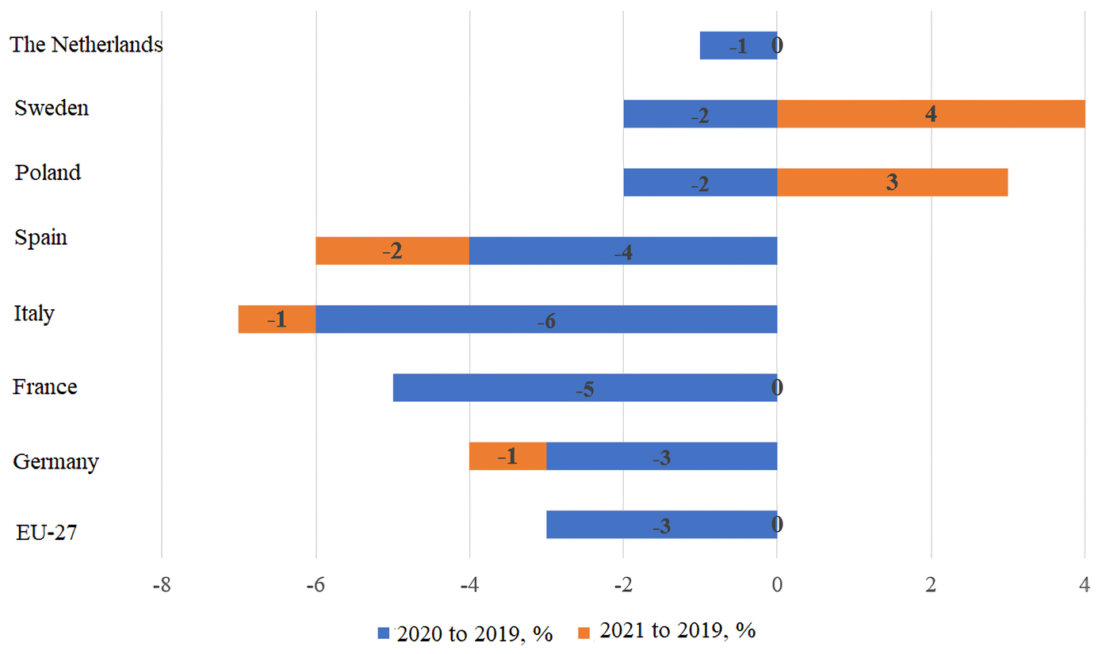
Note: the seven countries mentioned are the largest electricity consumers in the EU, accounting for 75% of total consumption volume

Figure 4. Structure of EU electricity generation by source, 2022, source: Compiled by the authors based on the Jones (2023)

Given that the REPowerEU plan necessitates substantial investments, the EU has mobilised approximately 300 billion euros (about 72 billion euros in grants and around 225 billion euros in loans) through the European Union's Recovery and Resilience Facility (RRF). This financing includes approximately 10 billion euros for missing gas and liquefied natural gas links, ensuring that any member country is left without heating, and up to 2 billion euros for oil infrastructure to halt Russian oil transportation. The remaining funding (95%) will be used to accelerate and broaden the scale of the transition to clean energy.
The impact of EU measures on Europe's energy markets will be investigated through an analysis of their dynamic development, the results obtained thus far, and the risks that may manifest in the future in the markets under consideration.
Also, as part of the transition of the European Union to clean energy, it is necessary to mention the problem of carbon neutrality. The European Green Deal has set a target of zero emissions by 2050 to combat climate change. The solution to this issue is closely related to the development of renewable energy sources, as their use reduces carbon emissions released during the operation of thermal power plants. It should be mentioned that two of the ten thermal power plants with the highest level of carbon emissions are located in the European Union, among them the record holder for emissions is the Belchatow Power Station, which, despite modernization, emitted 38 million tons of carbon in 2018 (Fox, 2021). The legal basis for the transition of the EU to a climate neutral state by 2050 is the European Climate Law. Also, the EU's commitment to transition to a climate-neutral state is mentioned in the Paris Agreement on climate change, the main goal of which is to reduce carbon dioxide emissions from 2020 (Long Term Strategy 2050, 2023).
Achieving carbon neutrality is fundamental not only to stabilizing the planet's temperature, but also to putting humanity on the path to sustainable development. The Sustainable Development Goals were established by the United Nations in 2015 and are a universal call to action to end poverty, protect the planet and ensure prosperity for all its inhabitants by 2030. Among the 17 interrelated global goals, carbon neutrality is closely linked to several of them, especially Sustainable Development Goal 13, which emphasizes combating climate change (Lee et al., 2020). The seventh sustainable development goal can be described as the need for affordable and clean energy, which is directly related to the issue of carbon neutrality, as countries gradually move away from fossil fuels in favor of renewable energy sources such as wind, solar and hydropower, which in turn , reduces the carbon footprint (UN Department of Economic and Social Affairs, 2023). To achieve carbon neutrality, the EU government uses the following economic instruments:
- abolition of fossil fuel consumption subsidies;
- a carbon pricing mechanism;
- government support for clean energy technologies (Antimiani et al., 2023).
Although Russia's aggression against Ukraine has delayed the EU's transition to clean energy, no one has questioned the trend toward carbon neutrality and the commitment to achieve it.

2. Current European energy markets

The pandemic's ramifications emerged as a primary driver of changes in the EU's energy system as early as 2020, in contrast to 2021, when the connection between the pandemic and electricity demand was already seen as minimal in the EU. In general, electricity demand fell during the 2020 lockdowns, particularly during the initial phase when offices were closed, industrial production was halted, and people stayed home (Figure 3).
Thus, following a 3.5% decrease (-100 TWh) in electricity demand in 2019-2020, there was a nearly complete recovery in 2021 (an increase of 3.4%, or +95 TWh), almost identical to the 2019 level. However, 2021 was colder than 2019, implying higher demand in the same conditions. This suggests that after the pandemic actual (weather-corrected) electricity demand did not fully recover. The rate of recovery varies by country. Demand in Spain remains noticeably lower (-2%) compared to the pre-pandemic period, while it has increased in Poland, Sweden, and Denmark (+3%, +4%, +7%, respectively).
We propose delving deeper into the energy sources used to generate electricity in the EU. Nuclear energy (22%) and gas (20%) received the highest share of the 2022 results (Figure 4).

2.1 Fossil fuel
In 2021, electricity production in the 27 EU countries using fossil fuels increased by 4% YoY (+43 TWh) to 1,069 TWh. The increase was primarily driven by a rise in demand of 95 TWh (+3%). Electricity produced from fossil fuel resources remained 6% (-64 TWh) lower than the pre-pandemic level of 2019, owing to continuous growth in Renewable Energy Sources (RES), particularly wind and solar generation, over the past two years (Jones, 2023). Due to the energy crisis, gas generation in the EU was more expensive than coal generation by mid-2021.
In 2021, fossil fuels comprised 37% of the EU's total electricity generation (up from 39% in 2019). The EU's share of electricity generation from natural gas fell to a three-year low of 18%, or 524 TWh. Coal-fired power plants generated 15% of total electricity in the EU (436 TWh), with coal generation decreasing by only 3% in 2019, compared to a 29% decrease in the previous two years. Prices for fossil fuels increased rapidly in 2021, fundamentally altering the electricity market. Gas prices increased by 585%, the largest jump since OPEC's 1973 oil embargo, due to numerous factors. Concurrently, coal and carbon tariffs experienced a substantial increase.
As a result, the cost of producing electricity from gas nearly sevenfold increased, causing a rapid rise in electricity prices across Europe. Since July, the price of gas-fired generation has surpassed the cost of coal-fired generation. Despite the increase in carbon tariffs, the explosive rise in petrol prices continued in the following months, and the cost differential widened. Using 2019 as a baseline, the increase in renewable energy generation caused the replacement of predominantly coal-fired generation in the first half of 2021. However, as the cost of gas energy rose in the second part of the year, new renewable capacity started replacing gas generation. Furthermore, there was a direct substitution of natural gas with coal in the second half of 2021, accounting for about 5% of total coal electricity generation in 2021.
Following coal, natural gas is the second-largest source of emissions in the energy sector. As a result, while natural gas could have an advantageous function in the short term by allowing the energy system to adapt to the variability of wind and solar influx, it will be necessary to phase out the use of natural gas by 2040 in order to transition to a clean energy system.
Gas energy played a significant role in generating electricity in the EU in 2022, contributing to 20% of the total electricity generation. Across the EU, gas energy production amounted to 557 TWh. Italy was the largest consumer of gas generation, producing 141 TWh, which accounted for 51% of its overall energy balance, making it the second-highest user of gas among EU countries. Malta had the highest proportion of gas energy in its energy balance, reaching 84%. However, its total gas production was relatively lower at 1.8 TWh compared to other EU countries (Jones, 2023).
While some countries have become less gas-dependent since 2015, Germany, Spain, France, and Italy, the largest electricity consumers, became convinced of the growing importance of gas production. Gas share of electricity generation in Italy increased by 12% (+30 TWh), while it increased by 6% (+32 TWh) in Germany.

2.2. Renewable generation
The volume of renewable generation resources in Europe is growing, with an average annual increase of 44 TWh over the last two years. Since 2019, more than half (52%) of these new renewable additions have replaced gas-fired power plants, one-third of nuclear power plants, and only one-sixth of coal-fired power plants. However, over 80% of the new renewable capacity implemented from 2011 to 2019 replaced coal generation. The increase in nuclear capacity restrictions and decommissioning since late 2019 has also slowed the rate of coal generation reduction. The most significant decrease in gas generation volumes was observed in the Netherlands and Spain (-24% and -18%, respectively), where the most significant increase in renewable energy production was also noted. Substantial reductions in gas generation have also been reported in Belgium (-17%) and France (-14%). In Spain, following the closure of coal-fired power plants with a total capacity of 6.5 GW (more than half of all coal capacity), the amount of electricity generated from coal nearly halved in 2019. A similar situation was in other countries, and all reductions were attributed to the closure of coal power plants. Romania, Czechia, Italy, Portugal, and Greece have each shut down 1-2 GW of capacity over the last two years. Unfortunately, the effect of power plant closures was offset by increased use of existing coal power plants in other EU countries. In Poland, electricity production from coal-fired power plants increased by 7% (+8 TWh) in 2019 due to increased domestic production and decreased electricity imports from neighbouring countries. Moreover, since August 2021, Poland has been a net exporter of electricity for the first time in 53 months, when it had to import electricity. The amount of coal generation in Ireland has also increased significantly as a result of coal replacing gas, a situation exacerbated by a series of outages at gas power plants. While renewable energy (RES) is setting new records, its growth is slowing. In 2021, the EU's electricity generation from RES set a new high of 1,068 TWh, up 1% (+12 TWh) from the previous year and 9% (+88 TWh) from 2019. In 2021, renewable energy sources accounted for 37% of total electricity generated in the EU (up from 34% in 2019).
Wind and solar generation have made the greatest contribution to renewable energy growth since 2019. For the first time, wind and solar power stations set a new record (547 TWh) in 2021, surpassing gas generation (524 TWh). In 2021, wind and solar energy accounted for 19% of total electricity generation in the EU (up from 17% in 2019). On the other hand, the 1% increase in wind and solar generation in 2020 appears to be modest. This is due to the wind speeds in 2021, which were lower than the EU average. The year 2020 was relatively windy, especially in the first quarter, emphasising the contrast with 2021. Wind generation volumes in the EU slightly decreased compared to 2019 (-2% or 10 TWh), resulting in only 0.3% of total electricity generated in the EU. The 10% increase in solar generation (+14 TWh) in Europe more than compensated for the decrease in wind generation, ensuring further growth in combined wind and solar generation.
Wind and solar capacity expansion in the EU-27 is accelerating, but weather conditions in 2021 have slowed production growth (Figure 5).
The production amounts of renewable energy sources (RES), such as solar and wind power plants, are expected to vary from year to year. Enhanced flexible grids, when combined with long-term energy storage systems (e.g. using green hydrogen), will ensure energy security in the context of an increasing share of variable sources. Wind and solar generation installed capacity in the EU continued to grow in 2021. It increased by 8% (+15 GW) for wind power plants and 16% (+22 GW) for solar power plants. Wind and solar power plants, on the other hand, were operational. Except for September, these stations set monthly records for electricity production in the EU in the second half of 2021. If compared to the second half of 2020, wind power plant results alone in an increase of energy production by two percent in the same period of 2021. The Netherlands, Greece, and Spain are the EU's new leaders in generating wind and solar energy. In each of these countries, the market share of wind and solar power plants increased by approximately ten percentage points in just three years, following a three-year slowdown in growth. In 2021, Spain generated approximately one-third of its electricity from solar and wind energy sources, while the Netherlands and Greece each contributed at least one-quarter. Despite accounting for only 16% of the total demand for electricity in the EU, these three countries have collectively driven over half of the growth in wind and solar power production since 2019.

Figure 5. Wind and solar energy capacity dynamics and production in the EU, source: compiled by the authors based on the Ember (2023)
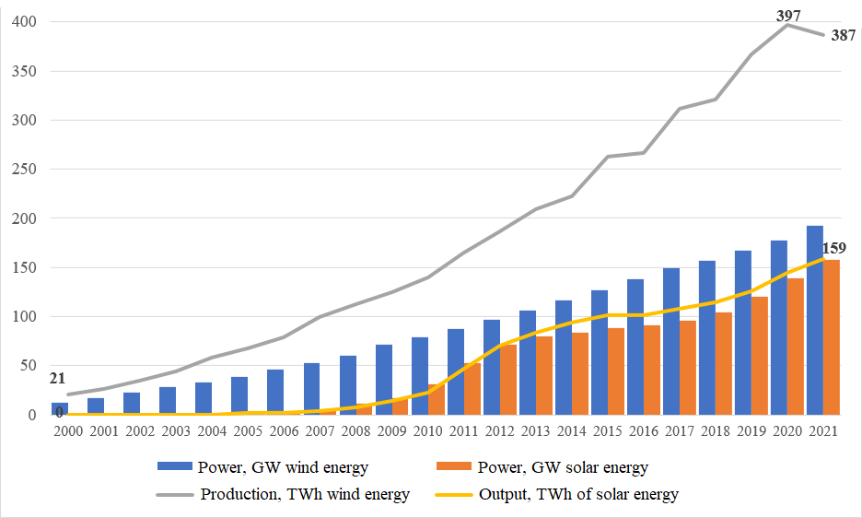

Wind and solar generation are increasing in the aforementioned countries due to favourable legislation, cost reductions, and ambitious goals set by these countries. Thus, Spain and the Netherlands intend to generate roughly two-thirds of their electricity with solar and wind power by 2030, while Greece is trying to raise its share to 50%. These plans contrast the situations in Poland and Italy, where renewable energy development is stalled. Additionally, the situation in Bulgaria, the Czech Republic, and Romania is also different since they have built virtually no renewable capacity.
In the bioenergy sector, there was very little growth after 2015 (EU legislation classifies bioenergy as renewable energy, despite recent scientific studies indicating that usage of many types of biofuels is associated with significant carbon emissions). In 2019-2021, the growth rate increased to 4% (+7 TWh), owing primarily to the co-combustion of biomass and coal in Netherland’s coal-fired power plants. In 2021, hydroelectric production continued to be broadly consistent with the previous year but was 9% higher (+28 TWh) than in 2019, when the water supply was relatively low.
In 2022, bioenergy production in the EU experienced a drop of 1.6%, which is equal to -2.8 TWh (Jones, 2023). It was the first time the EU experienced a decline in bioenergy production since the second half of the 1990s. Nevertheless, 2021 brought a moderate increase (+4.2 TWh, +6.7%). The most significant absolute reductions in generation took place in the Netherlands, Sweden, Denmark, Poland, Austria, and Italy. Meanwhile, Estonia experienced a 41% rise, resulting in an increase of 0.7 TWh. Increased energy generation in France, Finland, and Germany partially balanced out the reduction in EU bioenergy production, preventing more significant cuts.

2.3. Nuclear energy
In 2021, European nuclear power plants generated 733 TWh of electricity, a 7% increase (+47 TWh) compared to 2020 production. Simultaneously, nuclear power plant output was 4% lower (-32 TWh) than in 2019, owing primarily to planned reactor shutdowns. Nuclear energy accounts for approximately 22% of total electricity production in the European Union in 2022, compared with 29% a decade ago.
In 2022, nuclear energy production in the European Union experienced the most noticeable decline compared to 2021, decreasing by 16%, or 119 TWh. As a result, the share of nuclear electricity generation decreased by 3.5% in 2021p. The most notable but still comparatively small increases were recorded in the Netherlands, Finland, and Spain, constituting +0.4 TWh (9.4%), +1.5 TWh (6.2%), and +1.9 TWh (3.3%), respectively. The closure of nuclear power plants in Germany resulted in a 33 TWh (-47% reduction in generation). Due to high temperatures in rivers used for cooling during a heatwave in the summer of 2022, production at some French nuclear plants was decreased. Nuclear capacity was further lowered by planned maintenance. As a result, France's nuclear energy production was reduced by 82 TWh (22%), accounting for nearly 3% of total annual electricity production in the EU (Figure 6).

Figure 6. Highest nuclear energy share in EU electricity, % 2022, source: compiled by the authors based on the Jones (2023)
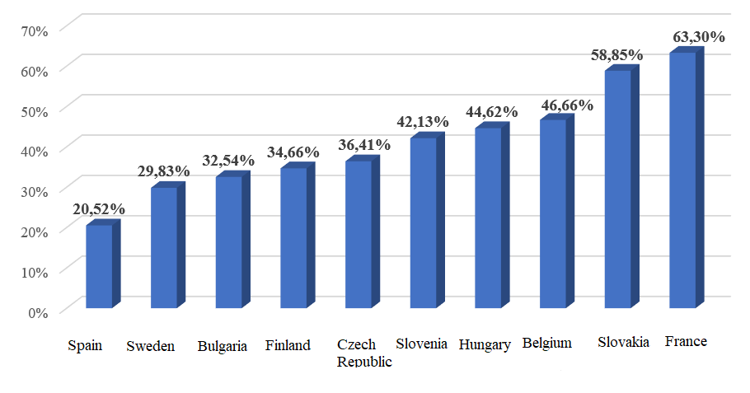

In summarising the results of the recent analysis of the development of European electricity generation, the following trends in this sector can be identified:
- the rapid decline in electricity demand as a result of both mandatory and voluntary energy conservation measures and the mild weather;
- reduction of coal generation in EU electricity production. Coal is still being gradually phased out of Europe;
- the beginning of rapid growth in solar generation. Wind and solar energy capacity increased, and production reached new highs in 2022. Both played critical roles in mitigating the financial, security, and climate consequences of the energy crisis, with solar energy leading in this regard;
- initially thought to be carbon-neutral, recent scientific data show that many forms of bioenergy pose a significant risk of substantial carbon emissions. Given these dangers, countries should aim to reduce or eliminate the integration of large-scale bioenergy into the energy sector;
- it is planned to reduce the share of gas in electricity production.

2.4. Gas market
The European Commission and member countries developed a comprehensive set of initiatives to address the energy crisis in 2022. These efforts continued into the fourth quarter of 2022, with the adoption of several additional measures, including increased solidarity through better coordination of gas procurement, the development of reliable price benchmarks to improve price transparency, the establishment of a market correction mechanism to manage episodes of excessively high prices, and the development of a framework to accelerate the deployment of renewable energy sources, thereby expediting the replenishment of gas in electricity generation and heating. This framework aided efforts to diversify the supply. Expansion of regasification capacities, reduction in demand, and storage filling ahead of the winter season resulted in a noticeable improvement in the market situation in the fourth quarter of 2022 (and even more so in the first quarter of 2023) (European Commission, 2023).
Following the termination of Nord Stream deliveries in the third quarter, imports of Russian pipeline gas stabilised at around 3-4 billion cubic metres per month, compared to 11-12 billion cubic metres per month in the fourth quarter of 2021. Russian pipeline gas imports decreased by around 15% in the fourth quarter of 2022, representing a drop of more than 25% from the same quarter in 2021. Its gas was mainly replaced by LNG imports (+13 billion cubic metres, or 70% per year) and additional pipeline imports, primarily Pipeline from Norway and the United Kingdom (Figure 7).
In the fourth quarter of 2022, the United States was the largest supplier of LNG to the EU, providing 13.2 billion cubic metres (36% of total LNG imports to the EU). During the same time period, the EU remained the world's largest liquefied natural gas (LNG) importer, surpassing Japan and China.
The average preservation level in Europe reached 91% in the fourth quarter of 2022, 29% higher than in the fourth quarter of 2021. The accelerated replenishment of reserves was aided by a 13% increase in LNG arrivals in the fourth quarter, which exceeded the already record-high imports in the third quarter. Additionally, it was supported by supplementary pipeline supplies, which helped compensate for the rapid decline in gas pipeline imports from Russia and significantly reduced gas consumption. Due to warm weather and delays at the beginning of the heating season, the peak was reached on November 13th (95.6%), nearly a month later than usual.

Figure 7. Dynamics of gas import deliveries to the EU from various sources, TWh/year, source: compiled by the authors based on the International Energy Agency (IEA) (2023)
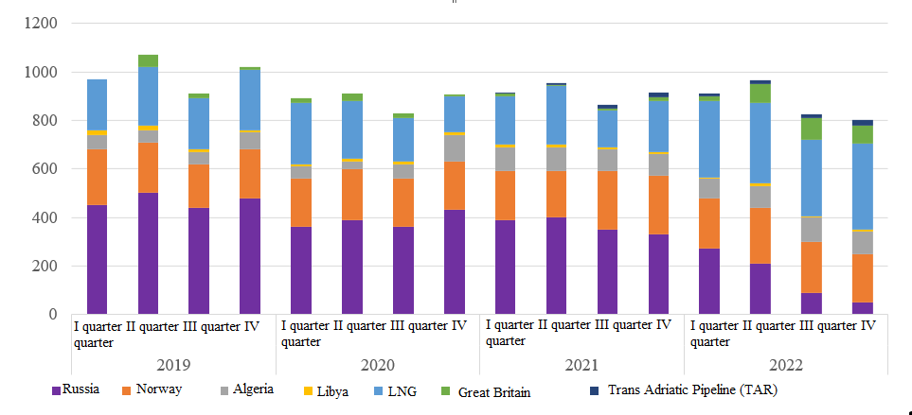
Gas consumption in the EU in the fourth quarter of 2022 decreased by 21% (-25 billion cubic meters) in the fourth quarter of 2022 compared to the same period the previous year, totalling 95.4 billion cubic metres.
For the first time since the beginning of the crisis, retail gas prices for residential consumers in many EU capitals decreased significantly during the fourth quarter of 2022. However, retail prices in other capitals continued to rise, and average prices increased at a much slower rate (3%) in the fourth quarter than in the previous quarter (which saw a 23% increase). The annual growth rate was 71%, down from 108% in the third quarter. The energy component's share of the price continued to rise, reaching 69% in the fourth quarter, up from 53% the previous year, as member countries stayed at lower taxes and fees.
Among the major European initiatives aimed at reducing tensions in the gas markets, the following should be pointed out:
- minimum preservation obligations: the European Union adopted a new resolution on gas storage in June 2022, requiring storage facilities to be filled to at least 80% of their capacity by the winter of 2022-23 and to 90% for all subsequent winter periods. Several EU member countries implemented even stricter rules in order to meet target indicators of more than 90%;
- the provision for coordinated actions to reduce gas demand: this aims to lower EU gas demand by 15% between August 1, 2022 and March 31, 2023, compared to the five-year average. The targeted reduction may become obligatory if the EU activates the crisis alert level;
- energy diplomacy: The European Union has stepped up its global efforts to strengthen its partnership with major natural gas and LNG suppliers, including Algeria, Azerbaijan, Norway, and the United States;
- the mechanism for joint gas purchases: adopted in December 2022, it will enhance collective gas procurement coordination through a two-stage process involving demand aggregation and voluntary participation in group procurement. In addition to the European Union, companies from the Energy Community Contracting Parties also can join the procurement mechanism;
- increased solidarity: in December 2022, the Council adopted new standard rules for allocating natural gas among EU member countries in the case of a genuine emergency. The default rules will take effect only if member countries do not reach bilateral agreements establishing conditions for solidarity;
- new floating storage and regasification units (FSRUs) and the expansion of existing regasification terminals: it will provide the European Union with 25% more regasification capacity in 2023 than in 2021, representing an annual increase of approximately 40 billion cubic metres;
- interconnectors: several interconnectors were commissioned before the 2022-2023 heating season, promoting internal gas flows and diversifying gas supply, including among Central and Southeastern European countries historically relying more heavily on Russian pipeline gas.
The present-day decision to resolve supply constraints will determine Europe's energy system's future. Deep integration and increased investment may help Europe overcome the crisis and accelerate the transition to cleaner, renewable, and more affordable energy sources.
However, the EU may face new risks in the coming years as a result of the gas supply crisis, rising demand, and increasing prices. According to a synthesis of international research, particularly by Jones (2023), the International Energy Agency (2023) and the European Commission (2022), these risks may include:
- Russian gas deliveries to the European Union will be halted entirely;
- the resumption of LNG imports by China to 2021 levels will result in a limited supply of additional LNG for the European Union – according to some estimates (International Energy Agency, 2023), only 4% (or 5 billion cubic metres) of extra LNG imports;
- increased demand (+10 billion cubic metres) in the residential and commercial sectors due to a cold winter (expected to be the lowest temperatures in two decades) in the fourth quarter of 2023;
- domestic gas production reduction in the EU.

Conclusions

The escalation of geopolitical conflicts has necessitated a reduction in Europe's strategic energy reliance. The current dual urgency to reduce energy dependency is also driven by the climate crisis, which is complicated by Russia's aggression against Ukraine and the EU's reliance on fossil fuels, which Russia uses as economic and political blackmail. As a result, the adopted REPowerEU plan envisions accelerated diversification and the increased use of renewable energy sources, as well as the implementation of energy efficiency and electrification measures, with the potential for rapid substitution of fossil fuel equivalents imported from Russia. This is achieved through coordinated planning in joint interests and is contingent on strong European solidarity.
In particular, reduced energy dependence can be achieved through a faster transition to clean energy. It has become abundantly clear that fossil fuels are no longer a satisfactory solution, as their use causes a rapid increase in electricity prices and poses risks to energy security. Particularly, coal energy has been increasing year after year, owing primarily to hydroelectric and nuclear energy issues rather than a desire to reclaim coal's role. Some coal units may have been placed on standby for the winter, but this is a one-time, exceptional measure that results in minimal generation. The anticipated coal resurgence did not take place, and current high stock levels will limit the need for coal imports until 2023. In Europe, the complete phase-out of coal is still ongoing.
In general, it is expected that the green transformation of Europe's energy system stimulates economic growth, strengthen industry leadership, and place Europe on track to reach climate neutrality by 2050. During the writing of the article, a connection was found between several sustainable development goals, which were defined by the United Nations, namely the seventh (clean energy) and thirteen (prevention of climate pollution) and the replacement of fossil fuels, in the process of transition to carbon neutrality. Russia's attack on Ukraine delayed the process of the EU's transition to clean energy, but the achievement of carbon neutrality still remained one of the main goals of sustainable development. The approach to modeling carbon neutrality in the EU is based on a revenue recycling mechanism to finance clean energy technologies.
The analysis also demonstrates the current results of the accelerated deployment of renewable energy sources. In particular, as part of the REPowerEU plan, the European Commission has proposed to raise the EU's renewable energy targets to 45% by 2030. Extraordinary measures in the power sector, such as reducing peak-hour electricity consumption, have resulted in an overall decrease in the use of gas for electricity generation and a reduction in price pressure, among other positive effects.
Without a doubt, the year 2022 was exceptionally difficult for the EU. The Russian invasion of Ukraine caused massive upheavals and an unprecedented energy crisis, resulting in a significant increase in living costs. It did, however, have one effect that has the potential to be beneficial in the long run: it caused the reduction of the reliance on Russian fossil fuel imports and encouraged the transition to clean energy and renewable sources.

References

- Antimiani A., Costantini V., Paglialunga E., 2023, Fossil fuels subsidy removal and the EU carbon neutrality policy, Energy Economics, 119, https://www.sciencedirect.com/science/article/pii/S0140988323000221.
- BILA С.О., 2018, Formation of the European Energy Space: Security and Integration Dimension.
- BLANK S.J., 2022, The Balkans and Euro-Atlantic energy security, Orbis, 66(1): 58-77, https://doi.org/10.1016/j.orbis.2021.11.006.
- CONSTANTIONI V., et al., 2007, Security of energy supply: Comparing scenarios from a European perspective, Energy Policy, 35(1): 210-226.
- EMBER, 2023, European Electricity Industry Overview, https://ember-climate.org/insights/research/european-electricity-review-2023/#supporting-material.
- EUROPEAN COMMISSION, 2021, Directive of the European Parliament and of the Council on energy efficiency, COM(2021) 558 final, 14.7.2021, https://eur-lex.europa.eu/resource.html?uri=cellar:a214c850-e574-11eb-a1a5-01aa75ed71a1.0001.02/DOC_1&format=PDF.
- EUROPEAN COMMISSION, 2022, Proposal for a Regulation of the European Parliament and of the Council establishing a framework for setting ecodesign requirements for sustainable products and repealing Directive 2009/125/EC, COM(2022), 142 final, 30.03.2022, https://opac.oireachtas.ie/Data/Library3/Documents%20Laid/2022/pdf/REVURWRvY3NsYWlkMjgwNDIyYV8yODA0MjJfMTAyMjU4.pdf.
- EUROPEAN COMMISSION, 2022, Communication on REPowerEU: Joint European Action for More Affordable, Secure, and Sustainable Energy, COM. (2022). 108 final.
- EUROPEAN COMMISSION, 2023, Energy. EU Policies Aim to Deliver Secure, Sustainable, and Affordable Energy for Citizens and Businesses, https://energy.ec.europa.eu/index_en.
- EUROPEAN COMMISSION, 2021, Proposal for a Council Recommendation on Ensuring a Fair Transition Towards Climate Neutrality COM(2021) 801 final.
- EUROPEAN COMMISSION, 2022, EU-US LNG Trade: US Liquefied Natural Gas (LNG) Has the Potential to Help Match EU Gas Needs, https://energy.ec.europa.eu/system/files/2022-02/EU-US_LNG_2022_2.pdf.
- EUROPEAN COMMISSION, 2022a, REPowerEU Plan, Communication from the Commission to the European Parliament, the European Council, the Council, the European Economic and Social Committee, and the Committee of the Regions, Brussels, 18.5.2022,
https://eur-lex.europa.eu/legal-content/EN/TXT/?uri= COM%3A2022%3A230%3AFIN&qid=1653033742483.
- EUROPEAN COMMISION, 2022b, Commission staff working document implementing the repower Eu Action Plan: Investment needs, hydrogen accelerator and achieving the bio-methane targets Accompanying the document Communication from the commission to the European Parliament, the European Council, the Council, the European Economic and Social Committee, and the Committee of the Regions REPowerEU Plan,
https://eur-lex.europa.eu/legal-content/EN/TXT/?uri=SWD%3A2022%3A230%3AFIN.
- EUROPEAN COMMISSION, 2023, Querly Report on European Gas Markets: With Focus on Price Developments in 2022, https://energy.ec.europa.eu/system/files/2023-05/Quarterly%20Report%20on%20European%20Gas%20Markets %20report%20Q4%202022.pdf.
- EUROPEAN COMMISSION, 2023a, The Green Deal Industrial Plan: Putting Europe's Net-Zero Industry in the Lead, https://ec.europa.eu/commission/presscorner/detail/en/ip_23_510.
- EUROPEAN COMMISSION, 2022, REPowerEU. Affordable, Secure and Sustainable Energy for Europe, https://commission.europa.eu/strategy-and-policy/priorities-2019-2024/european-green-deal/repowereu-affordable-secure-and-sustainable-energy-europe_en.
- EUROPEAN COMMISION & INTERNATIONAL ENERGY AGENCY, 2022, Playing my Part – How to save money, reduce reliance on Russian energy, support Ukraine and help the planet (IEA), https://www.iea.org/reports/playing-my-part?utm_content=buffer9b1c6&utm_medium=social&utm_source=twitter-ieabirol&utm_campaign=buffer.
- EUROPEAN COMMISSION, 2022, EU-US LNG Trade, https://energy.ec.europa.eu/system/files/2022-02/EU-US_LNG_2022_2.pdf.
- EUROPEAN COMMISSION, 2021, Proposal for a Council Recommendation on Ensuring a Fair Transition towards Climate Neutrality COM (2021) 801 final.
- EUROPEAN COUNCIL, 2022, European Sources Online, 24 and 25 March 2022, https://www.europeansources.info/record/european-council-24-25-march-2022/
- EUROPEAN LIME ASSOCIATION, 2023, Long Term Strategy 2050, https://eula.eu/resources/long-term-strategy-2050/.
- FOX A., 2021, Just 5 Percent of Power Plants Release 73 Percent of Global Electricity Production Emissions, Smithsonian Magazine, August 4, https://www.smithsonianmag.com/smart-news/five-percent-power-plants-release-73-percent-global-electricity-production-emissions-180978355/.
- Ghilès F., 2022, War in Ukraine and the Gas Crisis Force a Rethink of EU Foreign Policy, CIDOB, https://www.cidob.org/en/publication/war-ukraine-and-gas-crisis-force-rethink-eu-foreign-policy.
- International Energy Agency (IEA), 2023, Natural Gas Supply-Demand Balance of the European Union in 2023: How to Prepare for Winter 2023/24, https://www.iea.org/.
- JONES D., 2023,. European Electricity Review 2023, from: https://ember-climate.org/insights/research/european-electricity-review-2023/.
- LEE K. H., NOH J., KHM J. S., 2020, The Blue Economy and the United Nations’ sustainable development goals: Challenges and opportunities, Environment international, 137, https://www.sciencedirect.com/science/article/pii/ S0160412019338255.
- MOORE C., BROWN S., MACDONALD F., EN M., BRODBENT K., 2022, Energy Market in Europe: Key Trends, https://atomicexpert.com/european_energy_market_key_trends.
- PEREVEZOVA І. W., HRYNIV P.М., Dubovytskyi І.S., Khrabatyn А.V., Lastovets О.І., 2022, Impact of the Russian Invasion of Ukraine on the Energy Security of the EU, Scientific Notes of Lviv University of Business and Law. Series Economic. Series Legal, 34, http://dx.doi.org/10.5281/zenodo.7057469.
- PARLAMENT OSTEREICH, 2022, REPowerEU scenario in the staff working document Implementing the REPowerEU Action Plan: Investment Needs, Hydrogen Accelerator, and Achieving the Bio-methane Targets, accompanying this communication, https://www.parlament.gv.at/gegenstand/XXVII/EU/101030.
- RODRIGUEZ T. et al., 2014, Globalization and International Security: An Overview, NOVA Publishers, New York.
- SILVA A.C., 2014, Global Security Challenges for Europe: Structural and Strategic Changes in the Energy Markets and Major Implications, EUI Working Papers, RSCAS 2012/24, European University Institute Badia Fiesolana, http://cadmus.eui.eu/bitstream/handle/1814/22382/RSCAS_2012_24.pdf?sequence=1&isAllowed=y.
- Terazono E., Hume N., Files N., 2022, War in Ukraine: When political risks upturn commodity markets, Financial Times, https://www.ft.com/content/cf0212cf-21f3-4520-ae5f-136ce3f78afc.
- TERZIAN P., 2022, Scope and Consequences of the Russian Invasion of Ukraine, CIVILNET, 28 February 2022, https://www.civilnet.am/en/news/652021/scope-and-consequences-of-the-russian-invasion-of-ukraine/.
- Turchyn Ia., Ivasechko О., 2020, Energy security of the EU and Baltic states under conditions of the polyhedral foreign policy of the Russian Federation, Humanitarian Vision, 6(1), https://doi.org/10.23939/shv2020.01.001.
- UN Department of Economic and Social Affairs, 2023, The Sustainable Development Goals Report 2023: Special Edition, https://unstats.un.org/sdgs/report/2023/.
- Wołowiec T., Kolosok S., Vasylieva T., Artyukhov A., Skowron Ł., Dluhopolskyi O., Sergiienko L., 2022, Sustainable Governance, Energy Security, and Energy Losses of Europe in Turbulent Times, Energies, 15(23): 8857, https://doi.org/10.3390/en15238857.

