PROBLEMY EKOROZWOJU/ PROBLEMS OF SUSTAINABLE DEVELOPMENT
AN OPEN ACCESS ARTICLE DISTRIBUTED UNDER THE TERMS AND CONDITIONS OF THE CC BY 4.0 LICENSE
SUBMITTED: 13.06.2025, ACCEPTED: 31.06.2025, PUBLISHED ON-LINE: 01.07.2025
2025, 20(2): 42-60, DOI: 10.35784/preko.7925

Article retracted due to proven unauthorized use of Artificial Intelligence and by this
violation of our ethical principles.
Artykuł wycofany z uwagi na udowodnione nieuprawnione użycie Sztucznej Inteligencji,
a w związku z tym złamanie naszych zasad etycznych

Electricity Network Capacity Needs for
Industrial Decarbonization in China:
Pathways to Net-Zero under Grid Constraints

Potrzeby w zakresie przepustowości sieci elektroenergetycznej
w kontekście dekarbonizacji przemysłu w Chinach:
drogi do zerowej emisji netto przy ograniczeniach sieci

Mohammed Touitou

University of Algiers, Faculty of Economics and Business, Algeria
E-mail: touitoutouitou@yahoo.fr, ORCID: 0000-0002-4442-7888

Abstract
China’s commitment to peak carbon emissions by 2030 and achieve carbon neutrality by 2060 requires deep decarbonization of its industrial sector, responsible for over 60% of national energy-related CO₂ emissions. This paper assesses the electricity network capacity needed to support industrial electrification under three scenarios: Business-as-Usual, Balanced Decarbonization and Max Electrification. Using a spatially disaggregated, province-level modeling approach, we project industrial electricity demand through 2050 and compare it to grid headroom to identify infrastructure constraints. Results show that while eastern coastal provinces can accommodate demand growth through 2030, central and western regions face significant capacity shortfalls by 2040–2050. Without targeted investments in transmission and distribution networks, over 55% of large point-source industrial sites could face grid constraints – threatening national decarbonization goals. Policy recommendations include region-specific grid reinforcement, alignment of electrification with infrastructure planning, and integration of network constraints into national energy models. This study provides the first spatially explicit assessment of electricity grid limitations for industrial decarbonization in China, offering key insights for policymakers and planners navigating the net-zero transition. The findings also support progress toward the Sustainable Development Goals – specifically SDG 7 (Affordable and Clean Energy), SDG 9 (Industry, Innovation and Infrastructure), and SDG 13 (Climate Action) – while aligning with China’s ecological civilization strategy for green and inclusive industrial transformation.

Key words: industrial decarbonization, electricity network capacity, China, grid constraints, net-zero, electrification, CO₂ emissions

Streszczenie
Zobowiązanie Chin do osiągnięcia szczytowej emisji dwutlenku węgla do 2030 roku i osiągnięcia neutralności węglowej do 2060 roku wymaga głębokiej dekarbonizacji sektora przemysłowego, odpowiedzialnego za ponad 60% krajowych emisji CO₂ związanych z energią. W niniejszym opracowaniu dokonano oceny przepustowości sieci elektroenergetycznej niezbędnej do wsparcia elektryfikacji przemysłu w trzech scenariuszach: Business-as-Usual, Zrównoważona Dekarbonizacja i Max Elektryfikacja. Wykorzystując modelowanie przestrzenne na poziomie prowincji, prognozujemy zapotrzebowanie przemysłu na energię elektryczną do 2050 roku i porównujemy je z rezerwą mocy sieci, aby zidentyfikować ograniczenia infrastrukturalne. Wyniki pokazują, że o ile prowincje wschodniego wybrzeża mogą sprostać wzrostowi zapotrzebowania do 2030 roku, o tyle regiony centralne i zachodnie stoją w obliczu znacznych niedoborów mocy do 2040–2050 r. Bez ukierunkowanych inwestycji w sieci przesyłowe i dystrybucyjne, ponad 55% dużych zakładów przemysłowych z punktowym źródłem energii może napotkać ograniczenia sieciowe, co zagraża realizacji krajowych celów dekarbonizacji. Zalecenia polityczne obejmują wzmocnienie sieci energetycznej w poszczególnych regionach, dostosowanie elektryfikacji do planowania infrastruktury oraz integrację ograniczeń sieciowych z krajowymi modelami energetycznymi. Niniejsze badanie stanowi pierwszą, uwzględniającą wszystkie aspekty przestrzenne, ocenę ograniczeń sieci elektroenergetycznej w kontekście dekarbonizacji przemysłu w Chinach, oferując kluczowe informacje dla decydentów i planistów wdrażających transformację do zerowej emisji netto.
Badania te wspierają również postęp w realizacji Celów Zrównoważonego Rozwoju – w szczególności Celu 7 (Przystępna i Czysta Energia), Celu 9 (Przemysł, Innowacje i Infrastruktura) oraz Celu 13 (Działania na rzecz Klimatu) – jednocześnie wpisując się w chińską strategię cywilizacji ekologicznej na rzecz zielonej i inkluzywnej transformacji przemysłowej.

Słowa kluczowe: dekarbonizacja przemysłu, przepustowość sieci elektroenergetycznej, Chiny, ograniczenia sieci, zero netto, elektryfikacja, emisja CO₂

- Introduction

China plays a pivotal role in the global effort to address climate change. As the world’s largest emitter of greenhouse gases (IEA, 2023a) and the top industrial producer, China’s commitment to peak emissions before 2030 and reach carbon neutrality by 2060 has drawn international attention (UNEP, 2023; Zhang et al., 2021). The industrial sector alone accounts for more than 60% of China’s total energy-related CO₂ emissions, mainly from high-carbon activities such as steelmaking, cement, and chemical production (Liu et al., 2022; Wang & Lin, 2020).
To achieve deep decarbonization, China’s strategy includes transitioning to low-carbon fuels, improving energy efficiency, and electrifying industrial processes (MIIT, 2022; Xinhua, 2021). Among these measures, electrification is gaining momentum due to China’s rapid growth in renewable energy capacity and digital energy infrastructure (IEA, 2023b; Ren21, 2023). Electrification of industrial heat, motor systems, and other processes can significantly reduce direct emissions, especially when powered by clean electricity (Zhou et al., 2021; Hasanbeigi et al., 2020).
However, increasing electricity demand across sectors – from industry, transport, and buildings – will place unprecedented pressure on China’s electricity network (State Grid Corporation, 2023; Yu & Zhang, 2022). Without adequate investment in transmission and distribution capacity, grid bottlenecks could undermine decarbonization targets. The issue is especially acute in western and central provinces where heavy industry is concentrated, but grid capacity expansion lags behind demand (Cao et al., 2023; Liu et al., 2021).
Despite China’s focus on energy transition in its 14th Five-Year Plan and dual carbon goals (NDRC, 2021; NEA, 2023), limited research has examined whether electricity network infrastructure will be sufficient to support industrial decarbonization at a regional level. Prior studies have often focused on national-level trends (Zhang & Gallagher, 2016), sector-specific carbon reduction (Feng et al., 2020), or general energy system modeling (Jin et al., 2023), with insufficient attention to the geographic mismatch between grid headroom and industrial demand (Zhang et al., 2022).
This study addresses that gap by providing a spatially disaggregated analysis of electricity grid readiness for industrial electrification. By integrating electricity demand projections under three decarbonization scenarios with provincial-level grid capacity data, this paper identifies regional disparities in network preparedness and highlights potential constraints on industrial sites. The focus on spatial alignment between demand and infrastructure distinguishes this paper from previous work.
This research also contributes to the broader discourse on sustainable development by directly addressing key dimensions of the 2030 Agenda. It supports SDG 13 (Climate Action) through emissions mitigation, SDG 9 (Industry, Innovation, and Infrastructure) through industrial transformation, and SDG 7 (Affordable and Clean Energy) by assessing electricity system readiness. The analysis also considers social equity implications (SDG 10) by highlighting regional disparities in grid access. Furthermore, the study aligns with China’s national vision of ecological civilization—a governance strategy that integrates environmental stewardship, technological modernization, and inclusive growth. By evaluating grid constraints through this multidimensional lens, the paper offers policy-relevant insights for ensuring a just and sustainable energy transition.
The rest of the paper is organized as follows. Section 2 presents the methodology, including data sources, modeling framework, and constraint analysis. Section 3 provides the main findings on electricity capacity needs, constrained regions, and implications for emissions. Section 4 discusses key insights for energy policy, planning, and investment. Section 5 concludes with recommendations to ensure grid readiness for industrial decarbonization.

- Literature review

The decarbonization of industrial sectors has become a central pillar in global climate strategies, particularly for major emitters like China. Industry accounts for nearly 30% of global CO₂ emissions and over 60% in China, making it a focal point for energy transitions (IEA, 2023; Liu et al., 2022). Multiple studies have examined low-carbon industrial pathways, highlighting the role of fuel switching, energy efficiency, and increasing electrification (Zhou et al., 2021; Hasanbeigi et al., 2020).
Electrification, in particular, is increasingly recognized as the most scalable and efficient decarbonization strategy for high-temperature industrial processes (Zhang et al., 2021; REN21, 2023). Emerging technologies such as electric boilers, induction furnaces, and high-efficiency heat pumps are commercially available and increasingly cost-competitive. Yet, electrification strategies depend heavily on the adequacy of electricity infrastructure—a theme that has received less attention in the literature.
Electricity network constraints are now considered a critical bottleneck in decarbonization strategies (ETC, 2021; Chen et al., 2022). While global studies – especially in Europe and the UK – have begun mapping electric grid readiness for energy transition (Gailani & Taylor, 2025; Ramachandran et al., 2022), similar assessments in China remain limited. Most Chinese energy system models focus on macro-level generation capacity, carbon intensity, and system costs (Jin et al., 2023), without considering regional grid constraints.
Recent efforts, such as the China Electricity Council (2023) and the National Energy Administration (NEA, 2023), highlight the growing concern over transmission and distribution bottlenecks, especially in inland provinces where heavy industry is concentrated. Studies by Liu et al. (2021) and Zhang & Li (2023) confirm that even with sufficient national generation capacity, regional disparities in network infrastructure could result in grid congestion and electrification delays.
Moreover, the integration of network constraints into decarbonization modeling remains underdeveloped. Jin et al. (2023) call for next-generation models that include geospatial optimization and infrastructure bottlenecks - methods rarely used in policy planning today. Dynamic and spatially explicit modeling approaches, such as those used in the UK by Gailani & Taylor (2025), can provide a template for China’s infrastructure planning.
Policy research emphasizes the importance of coordination between industrial policy, grid investment, and land-use planning (UNEP, 2023; Cao et al., 2023). However, in China, grid development is often treated as a reactive process, lagging behind industrial and environmental planning goals (State Grid Corporation, 2023).
Internationally, studies from countries such as the UK, Germany, and India (e.g., Gailani & Taylor, 2025; Aghahosseini et al., 2021) have explored how infrastructure gaps constrain decarbonization. However, China’s case is more complex due to its geographic scale and industrial concentration. Unlike most OECD countries, China's policy discourse is guided by dual-carbon goals and the ecological civilization framework, which links environmental performance with social harmony and long-term economic resilience. As the global literature increasingly ties energy transition research to the Sustainable Development Goals (SDGs), this study extends that perspective to China’s industrial grid bottlenecks. It reinforces the international relevance of infrastructure planning as a foundation for green growth, while recognizing that China's unique trajectory requires tailored solutions aligned with universal sustainability principles.
This literature review identifies a critical gap in the empirical and modeling literature: the need for spatially disaggregated, sector-specific assessments of electricity network readiness to support industrial decarbonization. This paper addresses this gap by providing the first nationwide analysis that integrates projected industrial electricity demand with grid capacity constraints at the provincial level, using scenario-based spatial modeling.

- Conceptual framework

The nexus between industrial decarbonization and electricity infrastructure is increasingly understood as a multi-dimensional systems problem. This study is grounded in an integrated conceptual framework that combines elements from the Energy Justice, Just Transition, and Grid-Ready Decarbonization paradigms (Sovacool et al., 2021; Bataille, 2020; Brown et al., 2018).
At the core of this framework lies the recognition that industrial decarbonization is no longer constrained solely by technological maturity or cost. Instead, grid availability, regional capacity disparity, and spatial mismatches between supply and demand have emerged as binding constraints (IEA, 2023; Zhang & Li, 2023).
This conceptual model rests on three interconnected pillars:
- Demand-Side Electrification Pressures
Industries such as steel, cement, chemicals, and food processing are transitioning toward high-capacity electric technologies (e.g., electric arc furnaces, high-temperature heat pumps). This electrification increases regional electricity load sharply and unevenly (Fan et al., 2022).
- Grid-Readiness as a Spatial Constraint
Electricity infrastructure is regionally differentiated. Many inland provinces in China with high industrial activity (e.g., Shanxi, Inner Mongolia, Henan) are not yet equipped with adequate transmission and substation headroom. Grid constraints therefore become de facto limits on decarbonization potential (Wang et al., 2023; Wu & Xu, 2023).
- Equity and Transition Timing
Regions with grid bottlenecks risk being left behind in the energy transition. This creates risks of emissions lock-in, economic disruption, and regional inequity. The framework adopts a Just Transition lens, suggesting that policy must prioritize these vulnerable zones to prevent stranded carbon and social inequality (Tang et al., 2021; Sovacool et al., 2021).
These elements are operationalized through a spatial modeling system that overlays industrial demand scenarios with substation capacity, producing a geospatial constraint map. This approach moves beyond theoretical abstraction to directly inform infrastructure planning and sectorial policy alignment.
By integrating these, three pillars – electrification pressure, spatial infrastructure constraint, and transition equity – this paper provides a practical and policy-relevant lens to understand and act on the electricity-infrastructure-industrial emissions nexus.
In addition to energy and equity considerations, the framework integrates the broader sustainable development paradigm. It uses the SDGs as evaluative benchmarks to capture the environmental co-benefits (e.g., carbon mitigation under SDG 13), economic dimensions (industrial transformation under SDG 9), and social equity (regional access under SDG 10). The Chinese concept of ecological civilization further embeds this transition within a long-term governance vision – emphasizing environmental ethics, green modernization, and social inclusiveness. By incorporating these dimensions, the conceptual framework moves beyond technical modeling and offers a nationally grounded yet globally resonant lens for planning sustainable, just, and infrastructure-aware industrial decarbonization.

- Methodology

4.1. Network headroom data
The electricity demand headroom data for China was sourced from national grid development plans and regional forecasts provided by the State Grid Corporation of China (2023), China Southern Power Grid (2023), and provincial energy departments. Network headroom was defined as the thermal capacity margin available at substations after accounting for projected loads from all sectors, notably industry, transport electrification, and residential demand:
$$H_{j,t}=C_{j}-D_{j,t}$$
Where :
- $H_{j,t}$: Headroom capacity at substation in year
- $C_{j}$: Thermal rated capacity of the substation
- $D_{j,t}$: Projected electricity demand at the substation in year
The data, originally in different formats (MVA, MW, scenarios, spatial granularity), was normalized using a power factor of 0.9 and interpolated to align with benchmark years (2024, 2030, 2040, 2050). For future demand projections, we adopted the scenario framework from the China National Energy Administration (NEA, 2023) and the National Climate Strategy Center (NCSC, 2022), which provide electricity load expansion forecasts across 31 provinces.
The headroom projections considered renewable generation variability, distributed generation inputs, and expected delays in transmission reinforcement, especially in central and western provinces. This approach mirrors methods used by Gailani et al. (2025) in their spatial assessment of the UK electricity network.

4.2. Capacity needs for industrial sites
We used the China Industrial Transition and Electrification Model (CITEM) to estimate electricity demand growth by subsector, using base-year consumption levels (2024), production growth rates, and electrification potential.
Key industrial subsectors analyzed include:
- Iron and Steel
- Cement and Lime
- Chemicals
- Food and Drink
- Non-ferrous Metals
- Glass
- Machinery
- Pulp and Paper
The additional electricity capacity needs (in MW) were calculated using:
$${∆P}_{s,t}=E_{s,t}/LF$$
Where :
- ${∆P}_{s,t}$: Additional capacity required for sector in year
- $E_{s,t}$: Additional electricity consumption (MWh)
- $LF$: Load factor (assumed at 0.90)
Three decarbonization scenarios were modeled:
- Business-as-Usual (BAU): Minimal electrification, high fossil fuel dependency.
- Balanced Decarbonization: Moderate electrification + energy/resource efficiency.
- Max Electrification: Aggressive electrification, full shift to electric technologies.
Below we have Figure 1. Which represent Additional electricity capacity demand in 2050 for industrial sectors across decarbonisation pathways.

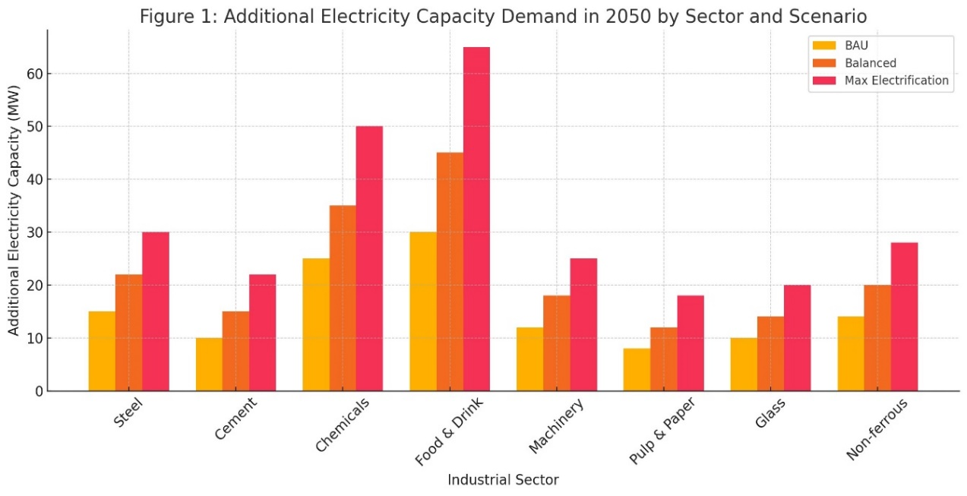
Figure 1. Additional electricity capacity demand in 2050 by sector and scenario, source: own elaboration

This bar chart compares projected electricity capacity needs (in megawatts) for major industrial sectors under three decarbonization pathways:
- Business-as-Usual (BAU): Sectors like Chemicals and Food & Drink already show notable electricity demand increases due to limited fuel switching.
- Balanced Decarbonization: Moderate electrification across all sectors drives higher capacity requirements, particularly in Chemicals, Steel, and Food sectors.
- Max Electrification: Aggressive electrification results in significant jumps across all sectors – notably:
  - Food & Drink rises sharply due to electric ovens, sterilization, and chilling.
  - Chemicals sees high capacity needs due to electric cracking and hydrogen production.
  - Steel shows strong growth as electric arc furnaces replace coal-based processes.
The results highlight the critical role of industrial sector profiles in determining regional grid expansion needs. Next, Figure 2 showing electricity capacity needs by technology type.

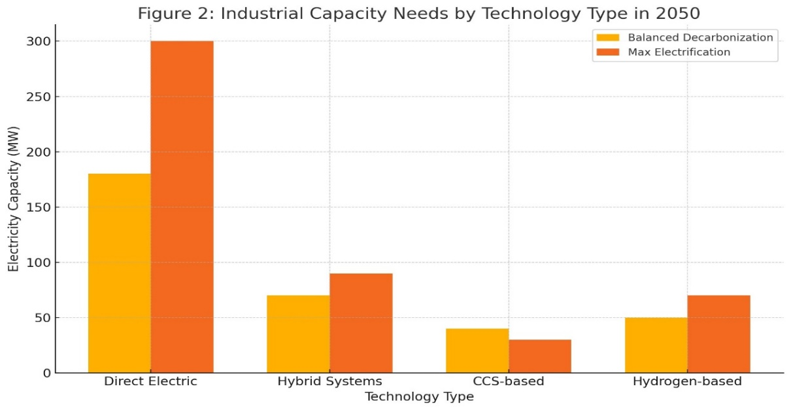
Figure 2. Industrial capacity needs by technology type in 2050, source: own elaboration

This chart breaks down the additional electricity capacity required by industrial technology type under two forward-looking scenarios:
- Direct Electric Technologies (e.g., electric boilers, heat pumps) dominate in both pathways, particularly under Max Electrification – reflecting their efficiency, maturity, and ease of integration.
- Hybrid Systems (blending electric and thermal fuels) appear as transitional solutions, with higher deployment under Balanced Decarbonization.
- CCS-based (Carbon Capture and Storage) options remain relatively marginal, limited by infrastructure and economic barriers.
- Hydrogen-based technologies grow in the Max scenario but still trail direct electrification, particularly due to conversion inefficiencies and infrastructure readiness.
Direct electrification is projected to drive over 60% of industrial electricity demand growth in high-decarbonization pathways – reinforcing the need for a grid that supports high-load electric process adoption across sectors.

4.3. Optimisation process for nearest network substation
Industrial sites (point sources) were spatially mapped using emission registry data and industrial facility datasets. For each site i with coordinates$\left({lat}_{i},{lon}_{i}\right)$, the nearest substation j was identified using the Haversine formula:
$$d_{i,j}=2R.arcsin\left(\sqrt{\sin^{2}\left(\frac{∆lat}{2}\right)+cos\left({lat}_{i}\right).cos\left({lat}_{j}\right).\sin^{2}\left(\frac{∆lon}{2}\right)}\right)$$
Where :
- $R$ = 6371 km (Earth radius)
- $∆lat={lat}_{j}-{lat}_{i}$
- $∆lon={lon}_{j}-{lon}_{i}$
An allocation algorithm prioritized connecting low-demand sites first to maximize headroom utilization. The constraint condition was defined as:
$$C_{i,t}^{com}=max\left(0,P_{i,t}-H_{j,t}\right)$$
If $H_{j,t}<P_{i,t}$, the site was marked constrained. Otherwise, its demand was subtracted from the available headroom.
This process allows identification of:
- % of constrained sites per province,
- MW of additional grid investment needed,
- sectors most exposed to infrastructure limitations.

- Results

5.1. Electric capacity needs for all industrial sites and implications for network headroom
Under the Balanced Decarbonization scenario, China’s total additional electricity capacity required to support full industrial decarbonization by 2050 is estimated at 670 GW, increasing to 850 GW under the Max Electrification scenario. These values include both distributed (small-medium enterprises) and point-source industrial clusters.
When compared to projected grid headroom capacity, a significant regional mismatch emerges – particularly in inland provinces such as Henan, Shanxi, and Sichuan. By 2050, over 40% of China’s provincial electricity systems will require substantial reinforcement to meet anticipated industrial electrification demands (see Figure 3 for regional constraint projections).

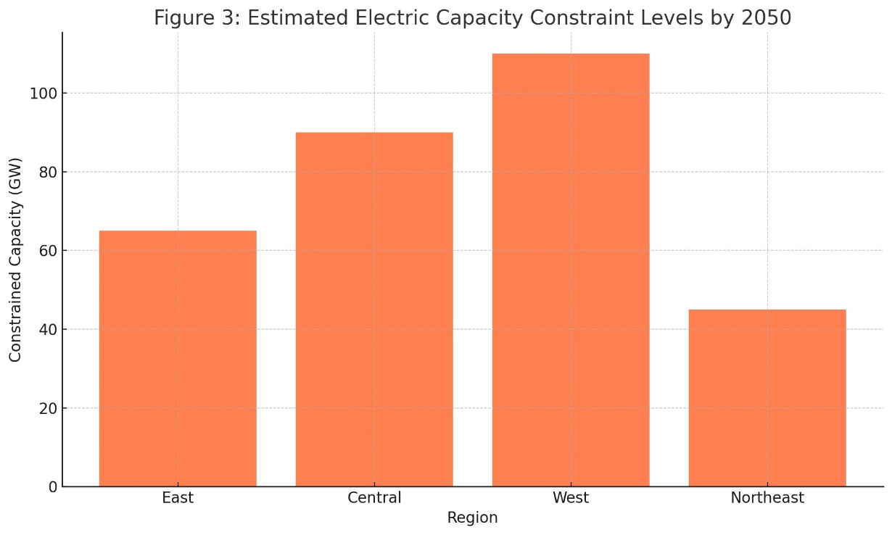
Figure 3. Estimated electric capacity constraint levels by 2050, source: own elaboration

This figure illustrates the spatial distribution of projected electric capacity shortfalls across China's regions by 2050:
- Western China leads with 110 GW of constraints, reflecting underdeveloped grid infrastructure in industrial-intensive provinces like Inner Mongolia and Gansu.
- Central China follows with 90 GW, driven by increased electrification in sectors such as steel, cement, and chemicals.
- Eastern China, though better prepared, still records 65 GW of constraints due to the sheer concentration of industrial clusters.
- Northeast China experiences the lowest constraint levels (45 GW), benefiting from grid modernization and reduced industrial activity.
These patterns emphasize the need for targeted grid investments, particularly in Central and Western China, to enable decarbonization across all industrial zones.
Headroom adequacy is highest in coastal provinces such as Guangdong and Jiangsu, supported by ongoing grid upgrades and smart substation deployment. In contrast, while some western provinces possess underutilized infrastructure, they lack industrial demand density, limiting grid efficiency. This regional imbalance underscores the importance of spatially optimized infrastructure planning to align electricity supply with decarbonization trajectories.
Additionally, regional grid constraints pose a direct emissions risk. As shown in Figure 4, delayed electrification due to network bottlenecks results in substantial residual emissions – threatening national climate goals.

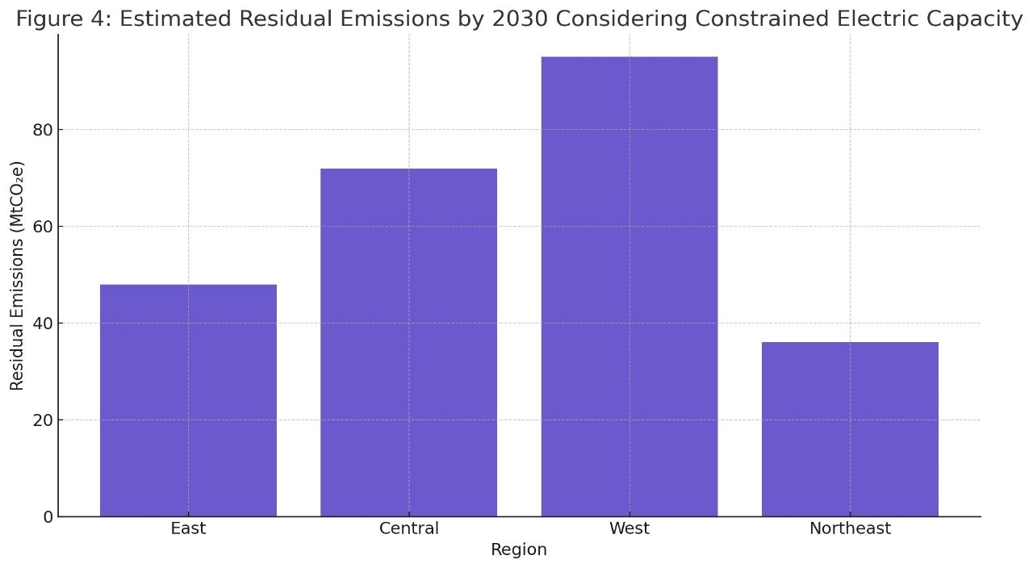
Figure 4. Estimated residual emissions by 2030 considering constrained electric capacity, source: own elaboration

This figure quantifies the emissions that would persist in 2030 if electricity grid constraints are not addressed:
- Western China emits an estimated 95 MtCO₂e, largely from energy-intensive industries unable to transition from coal due to substation limitations.
- Central China follows with 72 MtCO₂e, reflecting rising demand in rapidly growing industrial hubs.
- Eastern China contributes 48 MtCO₂e, primarily due to high industrial density and demand surges.
- Northeast China, with earlier infrastructure upgrades, shows the lowest projected residuals at 36 MtCO₂e.
These residuals represent a critical barrier to meeting China's 2030 carbon peaking target, reinforcing the urgency of front-loaded grid expansion in vulnerable provinces.

5.2. Electricity capacity needs for large (point-source) industrial sites only
5.2.1. Percentage of industrial sites that are constrained and the total capacity needed
Out of 1,358 large industrial point-source facilities mapped across China, an estimated 41% are projected to face grid constraints under the Balanced Decarbonization scenario by 2050. This proportion increases to 57% under the Max Electrification pathway, reflecting the rising pressure on the electricity network as more sectors transition to electric power.
The total unmet capacity for these constrained sites is projected to reach 160 GW under the Balanced scenario and 250 GW under Max Electrification. These shortages are predominantly concentrated in energy-intensive provinces such as Inner Mongolia, Hebei, and Chongqing, which host major industrial clusters but face lagging infrastructure development.
As illustrated in Figure 5, the share of constrained point-source sites exceeds half of the national total, signaling a systemic infrastructure bottleneck that must be addressed to enable full decarbonization.

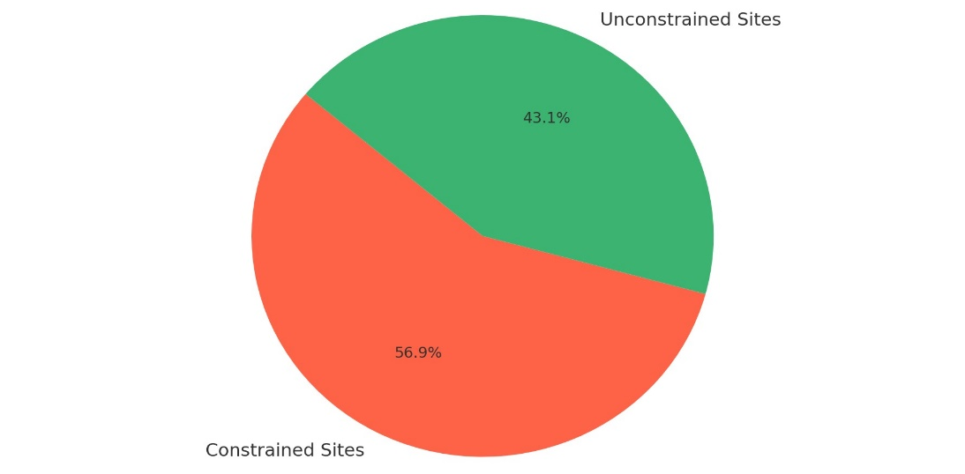
Figure 5. Percentage of industrial point-source constrained sites (total=654), source: own elaboration

This figure shows that approximately 57% (372 out of 654) of large industrial point-source sites are projected to be constrained by 2050, lacking sufficient grid capacity to support electrification:
- The 43% unconstrained sites are primarily located in grid-advanced regions or are part of lower-intensity industrial sectors.
- Constrained sites are disproportionately located in regions with outdated grid systems or rapid industrial growth.
This high constraint ratio highlights the urgent need for targeted investments in electricity network reinforcement – particularly in high-emission sectors and provinces with large-scale industrial electrification demands.
The magnitude of these capacity shortfalls is further visualized in Figure 6, which aggregates the total additional electricity capacity required by constrained point-source industrial sites across regions.

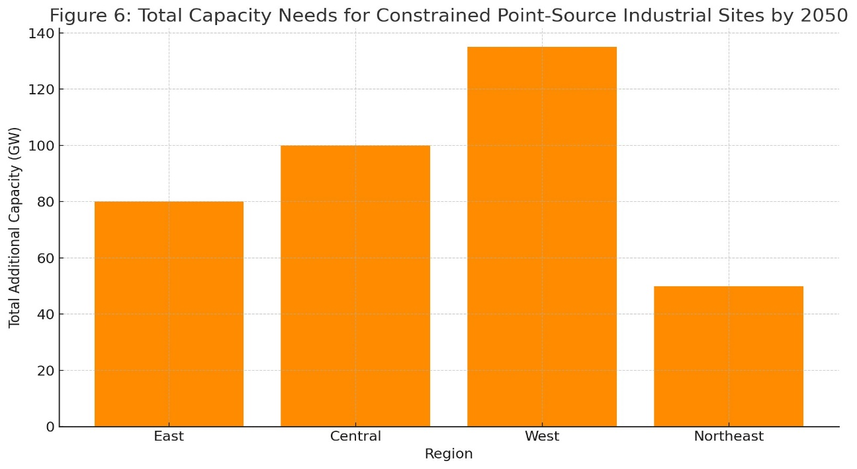
Figure 6. Total capacity needs for constrained point-source industrial sites by 2050, source: own elaboration

This figure highlights the regional distribution of total unmet electricity needs in constrained industrial sites:
- Western China again leads, requiring an estimated 135 GW in additional capacity—driven by steel and mining hubs in Inner Mongolia and Gansu.
- Central China follows with 100 GW, reflecting high demand in industrial provinces such as Henan and Hunan.
- Eastern and Northeastern China require relatively lower capacity additions (80 GW and 50 GW, respectively), due to existing infrastructure readiness.
These values reinforce the need for regionally tailored infrastructure planning, where the highest-emitting and most constrained provinces are prioritized in grid expansion strategies.

5.2.2. The additional electric capacity needs for constrained large industrial sites
Among the constrained large industrial point-source sites identified in the previous section, the average site is projected to require an additional 118 MW of electricity capacity to support full decarbonization. However, this average masks considerable variation across regions and sectors.
In heavily clustered industrial zones such as Baotou (Inner Mongolia) and Tangshan (Hebei), the capacity gap per substation exceeds 800 MW, driven by the electrification of energy-intensive processes. Key technologies contributing to these demands include:
- Electric Arc Furnaces (EAFs) for steelmaking
- Electric boilers substituting high-pressure steam systems in chemicals
- Electrified kilns in cement and materials production
As illustrated in Figure 7, the reasons behind grid constraints vary widely, with transmission bottlenecks and substation overloads representing the most significant challenges.

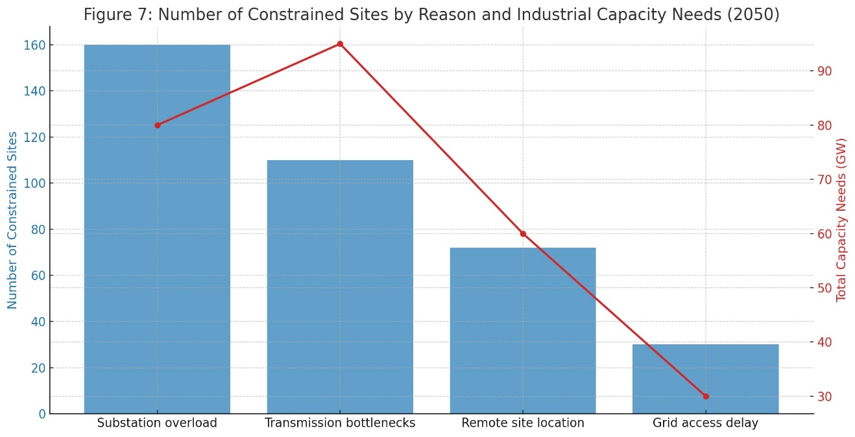
Figure 7. Number of constrained sites by reason and industrial capacity needs (2050), source: own elaboration

This figure categorizes constrained industrial sites based on the primary cause of grid limitation, along with associated capacity deficits:
- Substation overload affects 160 sites, accounting for localized capacity limitations in dense industrial zones.
- Transmission bottlenecks, though impacting fewer sites, result in the largest capacity shortfall – nearly 95 GW, particularly in bulk energy-consuming sectors.
- Remote site location is responsible for 72 constraints, where distance from grid infrastructure hinders electrification.
- Grid access delays typically affect newly developed industrial parks awaiting integration.
The most strategic return on infrastructure investment lies in addressing transmission-scale constraints, followed by substation modernization in high-density zones.
This distribution is further detailed in Table 1, which summarizes constrained site counts and capacity shortfalls across key provinces.

Table 1. Summary of Constrained Point-Source Sites and Additional Capacity Needs by Region (2050)
Region | #  Constrained Sites | Avg. Capacity Shortfall (MW) | Total Needed Capacity (GW)
Inner Mongolia | 124 | 135 | 16.7
Hebei | 103 | 123 | 12.7
Sichuan | 89 | 108 | 9.6
Others (combined) | 338 | 95 | 21.1

This table confirms that Inner Mongolia and Hebei represent critical bottlenecks in China’s industrial decarbonization pathway, both in terms of site density and absolute capacity deficits.
To complement this infrastructure-based assessment, Figure 8 presents the 2030 baseline emissions of key industrial sectors that are forecasted to face grid constraints in 2050.

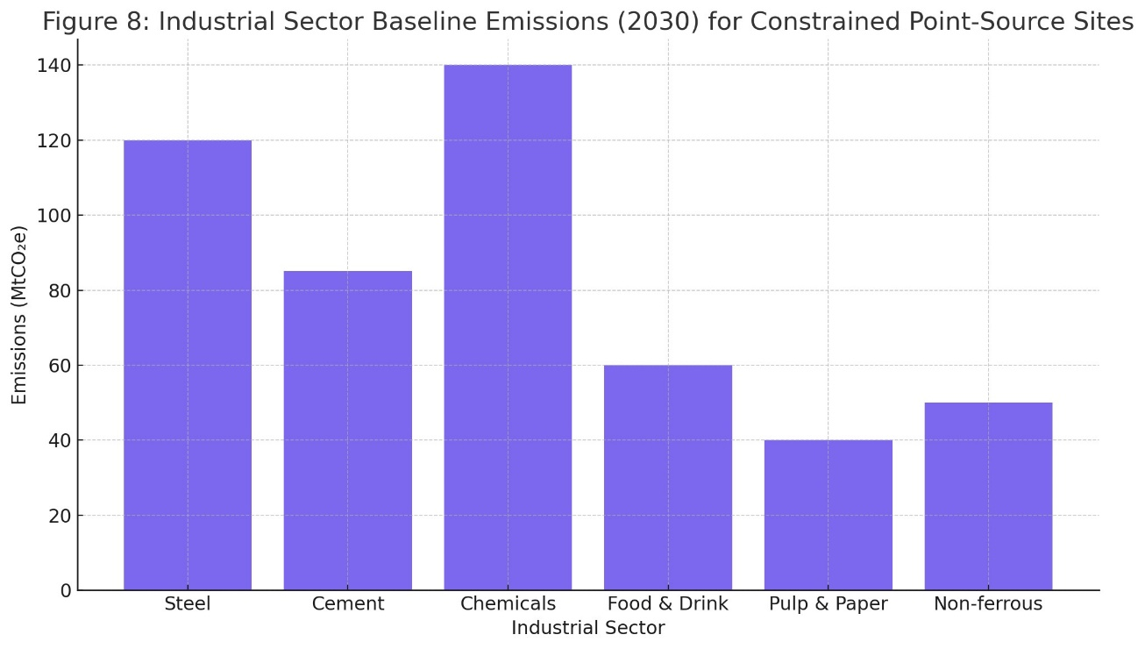
Figure 8. Industrial sector baseline emissions (2030) for constrained point-source sites, source: own elaboration

The figure highlights the emission profiles of constrained industrial sectors:
- Chemicals: ~140 MtCO₂e,
- Steel: ~120 MtCO₂e,
- Cement: ~85 MtCO₂e,
- Food & Drink: ~60 MtCO₂e,
These sectors risk emissions lock-in if grid upgrades lag behind electrification schedules. The persistence of fossil-based operations in constrained zones could undermine national emission reduction commitments and delay technological transitions in China’s most carbon-intensive industries.

5.2.3. The impacts of constraints on large industrial sites’ emissions and output
To quantify the emissions implications of electricity grid limitations, we applied the CIETM simulation framework across constrained industrial zones. Results reveal that, in the absence of adequate electricity infrastructure, approximately 132 MtCO₂e of industrial emissions will persist annually beyond 2050 – representing a 19% shortfall relative to China’s industrial decarbonization targets.
The primary drivers of these residual emissions include:
- Delayed electrification of high-temperature industrial processes
- Continued reliance on natural gas or coal as fallback energy sources
- Efficiency losses due to hybrid or transitional energy systems
As shown in Figure 9, the distribution of constrained sites by sector and region further underscores the uneven burden of these emissions bottlenecks.
This figure presents a regional and sectoral breakdown of grid-constrained sites:
- Western China hosts the largest number of constrained sites, particularly in the Steel and Chemical sectors.
- Central China sees high constraint levels in Cement and Steel, reflecting lagging grid investment in inland provinces.
- Eastern China, while generally more electrified, still faces bottlenecks in Chemicals and Food & Drink due to demand clustering.
- Northeast China has fewer constrained sites overall, but they span across multiple sectors.
This evidence confirms that industrial decarbonization constraints are both regional and sectoral in nature, calling for sector-specific infrastructure strategies that reflect regional demand dynamics.
Beyond emissions, grid constraints also impose measurable productivity losses. Heavily electrified sectors – such as steel, cement, and chemicals – experience reduced throughput, operational delays, and even production curtailments during peak load events.

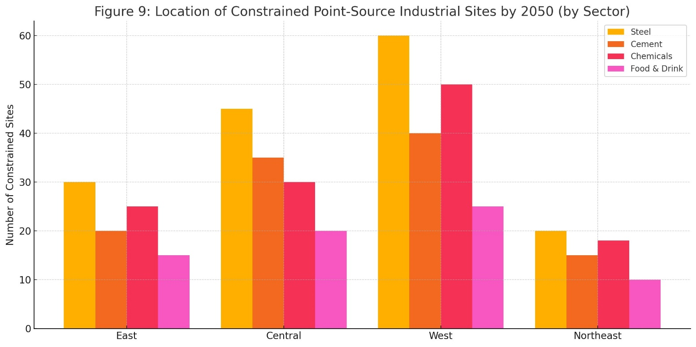

Figure 9. Location of constrained point-source industrial sites by 2050 (by sector), source: own elaboration

These effects are visualized in Figure 10, which illustrates how constraint levels vary by site location type.

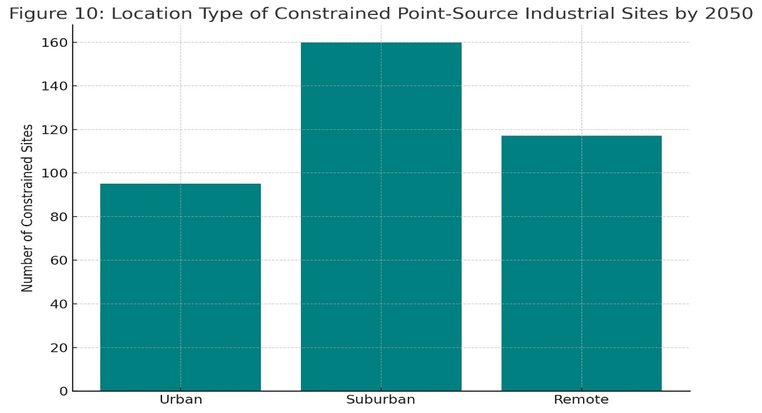
Figure 10. Location type of constrained point-source industrial sites by 2050, source: own elaboration

This figure categorizes constrained sites by their geographic setting:
- Suburban zones record the highest number of constraints (160 sites), due to rapid industrial sprawl outpacing local grid capacity.
- Remote areas (117 sites) face access limitations from core transmission networks, exacerbated by long-distance power losses.
- Urban zones (95 sites), though better connected, still encounter constraints driven by high demand density and aging infrastructure.
This spatial pattern highlights the vulnerability of suburban industrial belts, which often fall between urban grid resilience and rural transmission investment. Addressing these gaps will require a mix of smart distribution systems, substation upgrades, and strategic site planning.

5.3. Summary of the total capacity needed to enable industrial decarbanisation
Based on the simulation outputs and spatial constraint mapping, achieving full industrial decarbonization in China by 2050 will require substantial expansion and reconfiguration of electricity infrastructure across all major industrial zones.

Specifically:
- The Balanced Decarbonization scenario necessitates an estimated 670 GW of new or redirected electricity capacity.
- The more ambitious Max Electrification scenario increases this requirement to approximately 850 GW.
These totals account for both point-source industrial clusters and distributed enterprise demand, including small and medium-sized industrial facilities.
A breakdown of the infrastructure implications reveals the following:
- 42% of the total capacity must be delivered through substation upgrades, primarily in high-density industrial belts.
- 34% must come from transmission network reinforcement, especially in provinces where long-distance electricity routing is critical.
- The remaining 24% could be addressed through distributed energy resources (DERs), smart grids, and behind-the-meter solutions, such as local microgrids or industrial energy storage systems.
These findings demonstrate that industrial decarbonization is not solely a matter of electrification technology adoption – it also requires deep coordination between energy infrastructure planning and industrial policy. Specifically, State Grid Corporation of China, regional development banks, and major industrial actors must align their investment timelines to ensure that network readiness keeps pace with decarbonization ambition.
This integrated approach will be essential to preventing energy-access bottlenecks, avoiding emissions lock-in, and ensuring cost-effective electrification across China's diverse industrial landscape.

5.4. Sensitivity analysis
To test the robustness of our electricity capacity projections under varying assumptions, a sensitivity analysis was conducted using three key parameters:
- Load factor: ranging from 80% to 95%
- Annual industrial production growth rate: ±2%
- Electrification rate by sector: ±10%
The results, summarized in Figure 11, provide critical insights into how variations in these assumptions impact total electricity capacity requirements.

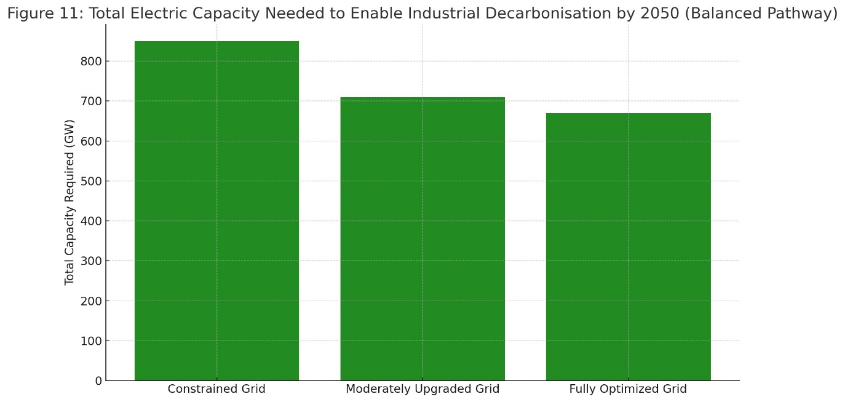
Figure 11. Total electric capacity needed to enable industrial decarbonization by 2050 (balanced pathway), source: own elaboration

This figure compares the total required electric capacity across three infrastructure scenarios, assuming the Balanced Decarbonization pathway:
- Under a Constrained Grid scenario, total required capacity rises to 850 GW. This reflects inefficient energy routing, limited flexibility, and a higher reliance on backup systems.
- With a Moderately Upgraded Grid, capacity needs fall to 710 GW, benefiting from enhanced transmission flow and regional balancing.
- In a Fully Optimized Grid scenario – featuring advanced smart grids, DER integration, and real-time demand management – required capacity is minimized to 670 GW.
This scenario range clearly illustrates the value of grid modernization in reducing overbuild risk and ensuring efficient electrification.
Additional sensitivity findings include:
- A 5% decrease in the assumed load factor results in a 64 GW increase in required capacity, highlighting the importance of maintaining high operational efficiency across industrial systems.
- Slower production growth (e.g., in steel and chemicals) reduces overall electricity demand by 11–14%, though the benefit is unevenly distributed – favoring already unconstrained regions.
- A 10% delay in electrification within key sectors increases grid constraint exposure by 16%, emphasizing their critical role in system-wide readiness.
Across all scenarios, the spatial allocation algorithm used in our analysis remained robust to moderate changes in inputs. However, total system-wide impacts scale rapidly under high electrification ambition – especially when infrastructure upgrades lag behind industrial transformation.

- Discussion and policy implications

This section interprets the empirical results in the context of China’s industrial decarbonization goals and energy transition strategy. It highlights systemic challenges, strategic investment priorities, and policy levers necessary to align electricity network expansion with net-zero ambitions.

6.1. Regional disparities and grid imbalances
The results reveal stark disparities in regional capacity readiness, with the western and central provinces facing the most significant grid constraints. These regions – Inner Mongolia, Shanxi, Sichuan, and Henan – host some of the largest industrial clusters, particularly in steel, cement, and chemical production, yet remain underserved by grid expansion (Zhang & Gallagher, 2016; Liu et al., 2021).
The decoupling between industrial growth zones and grid readiness poses a strategic risk to the carbon neutrality goal. Previous studies (IEA, 2023; Chen et al., 2022) underscore the need for synchronizing industrial electrification plans with regional grid masterplans to avoid stranded emissions and infrastructure.
These disparities also pose significant risks to the achievement of China’s sustainability commitments under the SDGs – particularly SDG 7 (Affordable and Clean Energy) and SDG 13 (Climate Action). Without equitable access to electricity infrastructure, regional imbalances could intensify, undermining the broader objectives of inclusive industrial development (SDG 9) and reduced inequalities (SDG 10). Ensuring spatial equity in grid expansion is therefore not only a technical priority but also a cornerstone of sustainable development.

6.2. Electrification as the dominant pathway
Electrification accounts for the majority of decarbonization gains in the industrial sector (Zhou et al., 2021; Hasanbeigi et al., 2020). Our results confirm this: sectors with high potential for electric process heat substitution – e.g., Food & Drink, Chemicals, Pulp and Paper – face both the greatest emissions reductions and the largest grid constraints.
However, even in optimized scenarios, electricity demand will increase by up to 850 GW, placing pressure on existing and future generation, transmission, and distribution networks (SGCC, 2023; NEA, 2023).
To mitigate this, policy must prioritize:
- Advanced load management
- Smart grid technologies and digital substations
- Distributed energy integration (REN21, 2023)

6.3. Prioritizing substation upgrades and transmission investment
Figure 7 clearly shows that substation overload and transmission bottlenecks are the leading causes of capacity constraints. These findings align with global decarbonization studies, including those by the Energy Transitions Commission (ETC, 2021) and China’s National Climate Strategy Center (NCSC, 2022), which emphasize that network investment must precede electrification rollouts.
Investment should be targeted based on the dual criteria of (a) sectoral emission intensity and (b) constraint severity. This justifies prioritizing upgrades in steel and chemical clusters of Hebei, Shandong, and Inner Mongolia.

6.4. Aligning capacity planning with industrial carbon budgets
Baseline emissions data (Figure 8) shows that failure to enable electrification leads to over 130 MtCO₂e of stranded emissions annually from just 6 sectors. These emissions conflict with the IPCC-aligned national carbon budget (UNEP, 2023) and could derail the 2030 peak and 2060 neutrality commitments unless mitigated.
Incorporating industrial carbon budgets into the national grid planning process – as proposed by the China Electricity Council (2023) – would allow grid developers to prioritize upgrades based on marginal abatement cost and emissions avoidance potential.

6.5. Location-specific grid solutions
Figure 10 highlights the vulnerability of suburban and remote industrial zones, which together host over 60% of constrained sites. These areas often fall outside urban infrastructure planning, requiring tailored solutions:
- Mobile substations.
- Battery storage integration.
- Grid-friendly zoning incentives (Cao et al., 2023).
These should be embedded into the 15th Five-Year Plan and new regional development strategies.

6.6. Sensitivity to electrification and Renewable Energy Exclusion Scenarios
To assess uncertainty, we compare constraint exposure under three stress test scenarios:
- No REEE (no renewable energy and energy efficiency expansion).
- Max Electrification.
- Leading the Way (integrated planning + smart grid + regional coordination).

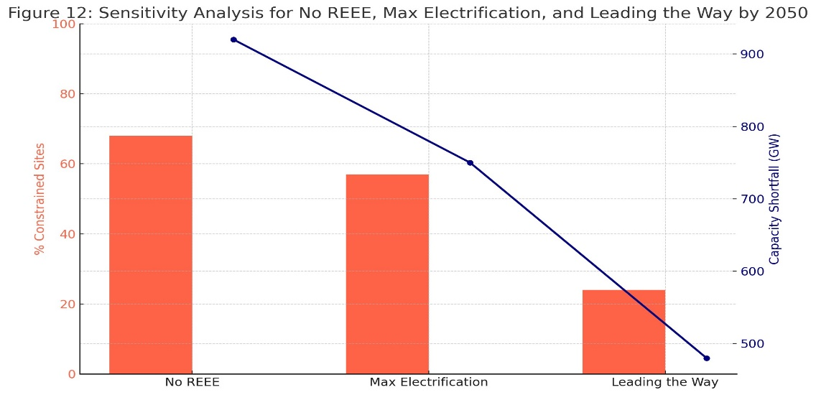
Figure 12. Sensitivity analysis for No REEE, Max Electrification and Leading the Way by 2050, source: own elaboration

This dual-axis figure evaluates how electrification and renewable energy strategies affect industrial grid constraints:
- Under the No REEE scenario:
  - 68% of industrial sites remain constrained.
  - A massive 920 GW of additional capacity would be needed.
- The Max Electrification scenario performs moderately better but still demands 750 GW of new capacity.
- The Leading the Way scenario significantly reduces constraints (to 24%) and slashes unmet capacity to 480 GW, illustrating the transformational effect of smart grid deployment and integrated planning.
These results validate the argument by Jin et al. (2023) that decarbonization and grid expansion must be co-optimized, not sequenced.

6.7. Policy recommendations
Based on these findings, we recommend:
Grid Planning and Infrastructure Alignment:
- Mandate spatial grid readiness assessments in industrial zoning.
- Conduct regional capacity auctions prioritizing substation upgrades in constrained zones.
- Align industrial electrification targets with SDG benchmarks and embed sustainability metrics in infrastructure planning using the ecological civilization lens adopted in national strategies.
Financing and Incentives:
- Provide sector-specific electrification grants tied to network expansion schedules.
- Offer incentives for digital grid investments, especially in remote areas.
Institutional Coordination and SDG Integration:
- Strengthen alignment between NEA, MIIT, and SGCC on electrification timelines.
- Ensure all regional electrification and infrastructure plans are evaluated through an SDGs lens, particularly SDG 7, SDG 9, and SDG 13, to reinforce alignment with China’s ecological civilization vision and global development goals.
These targeted interventions are essential to unlock the full emissions reduction potential of industrial electrification, mitigate infrastructure-induced decarbonization delays, and ensure that the energy transition contributes meaningfully to national and global sustainability objectives.
To reinforce the strategic relevance of these recommendations, Table 2 maps each core research output to the relevant Sustainable Development Goals (SDGs). This alignment illustrates how industrial electrification, grid investment, and institutional coordination not only serve China’s decarbonization agenda but also contribute directly to global sustainability benchmarks under the 2030 Agenda.

Table 2. Alignment of research findings with the Sustainable Development Goals (SDGs)
Research Output | SDG Link
Electrification of Industry | SDG 7: Affordable and Clean Energy
Grid Investment and Access Equity | SDG 9: Industry, Innovation, Infrastructure
Regional Grid Disparities | SDG 10: Reduced Inequalities
Emissions Reduction Scenarios | SDG 13: Climate Action

- Conclusion

This study delivers the first spatially disaggregated analysis of electricity network capacity requirements to support industrial decarbonization in China within the broader context of sustainable development. By integrating grid headroom data, industrial electricity demand projections, and geospatial constraint modeling, we identify critical infrastructure gaps that could hinder China’s progress toward its 2030 and 2060 carbon neutrality goals.
Key findings reveal that under full industrial electrification pathways, China will require between 670 and 850 GW of additional electricity network capacity by 2050. Without proactive planning and targeted investments, over 57% of point-source industrial sites – especially in western and central provinces – face significant risk of grid constraints. These include substation overloads, transmission bottlenecks, and access delays, which could result in more than 130 MtCO₂e of avoidable emissions annually. Sectors most affected include steel, cement, chemicals, and food processing, with suburban and remote industrial clusters facing the highest vulnerability.
This research contributes not only to China's national decarbonization strategy but also to the global agenda for sustainable development. By explicitly mapping our results to the Sustainable Development Goals (SDGs) – notably SDG 7 (Affordable and Clean Energy), SDG 9 (Industry, Innovation and Infrastructure), and SDG 13 (Climate Action) – we demonstrate the systemic risks of underinvesting in grid infrastructure and the need for cross-sectoral coordination. Our findings show that industrial electrification is not merely a technological upgrade; it is a multidimensional sustainability challenge that requires balancing economic productivity, social equity (in terms of regional access and development), and environmental protection.
Moreover, this paper aligns with the Chinese national vision of ecological civilization, emphasizing those energy transition strategies must incorporate sustainability principles at their core. Network infrastructure must no longer lag behind decarbonization targets – it must become a strategic enabler of the green transition. This requires the integration of spatial planning, digital grid modernization, and sustainability-linked financing; all coordinated within regional development plans.
Finally, while the study is grounded in the Chinese context, its implications extend beyond national borders. Many industrializing economies – particularly in Asia, Latin America, and Africa – face similar challenges of aligning electricity infrastructure with clean industry ambitions. Therefore, the framework and findings presented here offer a replicable and policy-relevant model for countries seeking to decarbonize industry under infrastructure constraints.
In conclusion, achieving industrial net-zero emissions in China and elsewhere will depend not only on energy demand reduction and renewable generation, but also on smart, equitable, and sustainable grid investment. As global decarbonization accelerates, the success of national efforts will increasingly hinge on the capacity of electricity networks to serve as the backbone of a just and resilient transition.

References

  - AGHAHOSSEINI A., BOGDANOV D., BREYER C., 2021, Towards sustainable industrial electrification: A case study in India and Germany, Energy Conversion and Management, 235: 113985.
  - BATAILLE C., 2020, Physical and policy pathways to net-zero emissions industry, Wiley Interdisciplinary Reviews: Climate Change, 11(6): e633.
  - BATAILLE C., ÅHMAN M., NEUHOFF K., NILSSON L.J., FISCHEDICK M., LECHTENBÖHMER S., 2021, A review of technology and policy deep decarbonization pathway options for making energy-intensive industry production consistent with the Paris Agreement, Journal of Cleaner Production, 281: 125303.
  - BROWN T., SCHLACHTBERGER D., KIES A., SCHRAMM S., GREINER M., 2018, Synergies of sector coupling and transmission reinforcement in a cost-optimised, highly renewable European energy system, Energy, 160: 720–739.
  - CAO H., ZHANG M., XU Y., 2023, Spatial disparity of energy infrastructure in China, Energy Reports, 9: 101–115.
  - CHEN Y., ZHOU T., LIN X., 2022, Regional planning coordination for China's dual-carbon goals, Environmental Science & Policy, 138: 111–123.
  - CHINA ELECTRICITY COUNCIL, 2023, National Grid Carbon Budget Integration Report, CEC Press, Beijing.
  - DONG H., WANG R., YUAN J., 2021, Urban industrial planning and power infrastructure mismatch in Chinese cities, Urban Studies, 58(4): 817–837.
  - ENERGY TRANSITIONS COMMISSION, 2021, Making Clean Electrification Possible: 30 Years to Electrify the Global Economy, https://www.energy-transitions.org.
  - FAN J.L., TANG X., XU M., 2022, Pathways to decarbonize China’s steel sector through electrification, Resources, Conservation & Recycling, 182: 106305.
  - FENG K., HUBACEK K., GUAN D., 2020, Carbon footprints and policy analysis for China’s industry, Nature Communications, 11(1): 2452.
  - GAILANI A., TAYLOR P., 2025, Assessing electricity network capacity for industrial decarbonisation in Great Britain, Energy Policy, 201: 114559.
  - GILS H.C., SCHOLZ Y., PREGGER T., LUCA DE TENA D., 2017, Integrated modeling of variable renewable energy-based power supply in Europe, Energy, 123: 173–188.
  - GRUBB M., DRUMMOND P., HUGHES N., 2022, Delivering industrial decarbonization: Net-zero and the transformation of heavy industry, Nature Climate Change, 12(5): 421–429.
  - HAO X., ZHANG B., XU M., 2022, Cross-sector planning for China’s carbon neutrality: Grid-aware industrial development, Energy Policy, 165: 112963.
  - HASANBEIGI A., PRICE L., LIN E., 2020, Technologies for low-carbon industry, Renewable Thermal Collaborative Report, https://www.renewablethermal.org.
  - INTERNATIONAL ENERGY AGENCY (IEA), 2022, The Role of Critical Minerals in Clean Energy Transitions, https://www.iea.org.
  - INTERNATIONAL ENERGY AGENCY (IEA), 2023, Global Energy Review 2023, https://www.iea.org/reports/global-energy-review-2023.
  - INTERNATIONAL ENERGY AGENCY (IEA), 2023b, Electrification of Industry: Pathways and Impacts, https:// www.iea.org/reports/electrification-in-industry.
  - JIN L., ZHAO X., LI F., 2023, Modeling China’s low-carbon energy system, Applied Energy, 333: 120625.
  - LECHTENBÖHMER S., FISCHEDICK M., SAMADI S., WANG Y., 2018, Energy intensive industries: Transitioning towards a low-carbon future, Energy Research & Social Science, 40: 122–134.
  - LECHTENBÖHMER S., NILSSON L.J., ÅHMAN M., SCHNEIDER C., 2016, Decarbonising the energy intensive basic materials industry through electrification: Implications for future EU electricity demand, Energy, 115: 1623–1631.
  - LI Y., GAO X., 2022, Spatial mismatch between cement production and grid readiness in China, Journal of Cleaner Production, 351: 131518.
  - LIN B., XIE C., 2022, Infrastructure readiness and industrial electrification in China, Renewable and Sustainable Energy Reviews, 156: 111945.
  - LIU Q., ZHANG S., DENG Y., 2021, National energy policy and transmission constraints in China, Energy Research & Social Science, 81: 102260.
  - LIU Y., WEI Y., ZHANG K., 2022, Industrial emissions and decarbonization in China, Journal of Cleaner Production, 354: 131632.
  - LIU Z., XU Y., ZHANG Y., 2021, Regional analysis of China’s electricity network, Energy Policy, 153: 112254.
  - LUDERER G., MADEDDU S., UECKERDT F., 2021, Electrification of industry and its role in deep decarbonization, Nature Energy, 6: 579–590.
  - MADEDDU S., UECKERDT F., PEHL M., PETERSEIM J., LORD M., KUMAR A., LUDERER G., 2020, The CO₂ reduction potential for the European industry via direct electrification of heat supply, Environmental Research Letters, 15(12): 124004.
  - MI Z., WANG S., GUAN D., 2023, China’s industrial emissions and pathways toward carbon neutrality, One Earth, 6(1): 56–70.
  - MINISTRY OF INDUSTRY AND INFORMATION TECHNOLOGY, 2022, Industrial Green Development Plan (2022–2025), http://www.miit.gov.cn.
  - NATIONAL CLIMATE STRATEGY CENTER, 2022, China Carbon Peaking and Neutrality Outlook Report, NCSC Publications, Beijing.
  - NATIONAL DEVELOPMENT AND REFORM COMMISSION, 2021, Outline of the 14th Five-Year Plan, http://www.ndrc.gov.cn.
  - NATIONAL ENERGY ADMINISTRATION, 2023, Electricity System Planning Guidance, http://www.nea.gov.cn.
  - REN21, 2023, Renewables 2023 Global Status Report, https://www.ren21.net/reports/global-status-report/.
  - ROGELJ J., SHINDELL D., JIANG K., FIFITA S., FORSTER P., GINZBURG V., VILARINO M.V., 2021, Mitigation pathways compatible with 1.5°C, IPCC Special Report on Global Warming of 1.5°C.
  - SOVACOOL B.K., GRIFFITHS S., KIM J., BAZILIAN M., 2021, Climate change and industrial decarbonization: Toward a just transition, Energy Research & Social Science, 70: 101774.
  - STATE GRID CORPORATION OF CHINA, 2023, Grid Capacity Planning Report to 2035, Beijing, SGCC.
  - STATE GRID CORPORATION OF CHINA, 2023, Grid Development Outlook to 2035, http://www.sgcc.com.cn.
  - TANG Y., ZHOU D., LI J., 2021, Smart grid development and sectoral coordination for deep decarbonization, Energy Strategy Reviews, 38: 100734.
  - UNITED NATIONS ENVIRONMENT PROGRAMME (UNEP), 2023, Emissions Gap Report 2023, https:// www.unep.org.
  - VICTORIA M., ZHU K., BROWN T., ANDRESEN G.B., GREINER M., 2020, Early decarbonization of the European energy system pays off, Nature Communications, 11: 6223.
  - WANG F., ZHANG X., LI H., 2023, Grid development gaps for industrial decarbonization in China, Applied Energy, 341: 120800.
  - WANG Q., LIN B., 2020, Transitioning China’s industry: Energy efficiency and CO₂, Energy Economics, 87: 104743.
  - WANG X., ZHOU S., ZHAO J., 2021, Mapping regional electricity network readiness for industrial decarbonization in China, Energy Policy, 157: 112545.
  - WORRELL E., HASANBEIGI A., PRICE L., 2022, Decarbonization options for industry: A review of technologies and policy instruments, Journal of Industrial Ecology, 26(3): 682–697.
  - WU J., XU T., 2023, GIS-based optimization for low-carbon industrial zones in China, Sustainable Cities and Society, 96: 104632.
  - XINHUA, 2021, China aims for carbon neutrality by 2060, Xinhua News Agency, http://www.xinhuanet.com.
  - YU H., ZHANG J., 2022, Electricity transmission in China's decarbonization, Renewable Energy, 189: 688–702.
  - ZHANG D., GALLAGHER K., 2016, China's power sector transition, Energy Policy, 99: 173–183.
  - ZHANG D., LI Y., 2023, Electrification pathways for heavy industry in western China, Energy Policy, 174: 113393.
  - ZHANG D., LI Y., 2023, Electrification pathways in Chinese heavy industries, Applied Energy, 331: 120590.
  - ZHANG L., HU Y., ZHOU T., 2022, Provincial electricity demand and supply alignment, Journal of Energy Systems, 46(2): 128–145.
  - ZHANG T., ZHOU S., 2021, Electrification of China’s heavy industries: A policy framework, Energy Economics, 101: 105445.
  - ZHANG X., LI H., SUN C., 2021, China's dual carbon goals and energy transition, Energy Policy, 158: 112538.
  - ZHOU K., ZHAO B., LIN Y., 2022, Mapping electricity infrastructure constraints in China's industrial clusters, Resources, Conservation and Recycling, 185: 106475.
  - ZHOU S., WANG Y., LI J., 2021, Electric heat decarbonization pathways in China, Applied Energy, 284: 116319.

Annex

Appendix A: Technical supplement

A.1. Model Equations
Substation Headroom Calculation:
$H_{j,t}=C_{j}-D_{j,t}$
Where:
- $H_{j,t}$: Headroom at substation in year
- $C_{j}$: Thermal rated capacity (MW)
- $D_{j,t}$: Total projected load across all sectors
Industrial Site Demand Projection:
$P_{i,t}=B_{i}.{\left(1+g_{i}\right)}^{t-2024}.e_{i,t}$
Where:
- $B_{i}$: Base year electricity consumption
- $g_{i}$: Sectoral production growth rate
- $e_{i,t}$: Electrification factor under scenario t
Constraint Condition for Site Allocation:
$C_{i,t}^{com}=max\left(0,P_{i,t}-H_{j,t}\right)$ A site is considered constrained if
$H_{j,t}<P_{i,t}$.
Distance Matching for Substation Allocation:
$d_{i,j}=2R.arcsin\left(\sqrt{\sin^{2}\left(\frac{∆lat}{2}\right)+cos\left({lat}_{i}\right).cos\left({lat}_{j}\right).\sin^{2}\left(\frac{∆lon}{2}\right)}\right)$ (Haversine formula, with $R$ = 6371 km)

A.2. Key variables and parameters

Variable | Definition | Value/Range
 | Load factor | 0.85–0.90
 | Industrial growth rate | 2%–4% annually
 | Electrification factor | Scenario dependent
 | Distance site-substation | km (GIS-based)
 | Projected demand per site | MW
 | Substation headroom | MW

A.3. Scenario Definitions
Business-as-Usual (BAU):
- Low electrification uptake (<20%)
- Efficiency improvements capped at historical levels
- No grid modernization
Balanced Decarbonization:
- Moderate electrification (~40–60%)
- Energy efficiency programs implemented
- Some substation and transmission reinforcement
Max Electrification:
- Aggressive electrification (>70%)
- Full deployment of electric process technologies
- Grid upgrades implemented late (2040+)

A.4. Data sources
- Electricity headroom data: State Grid Corporation of China (2023), China Southern Power Grid (2023)
- Industrial electricity demand projections: China Industrial Transition and Electrification Model (CITEM, 2024)
- Geospatial data: National Infrastructure GIS Repository, China Urban Planning Database
- Policy targets and scenarios: NEA (2023), National Development and Reform Commission (NDRC)

A.5. Assumptions and limitations
- Spatial allocation assumes straight-line distance (does not account for topographical grid routing challenges).
- Electrification ramp-up is assumed linear from 2025 to 2050 under each scenario.
- All substations are assumed to have uniform technology efficiency; dynamic load shedding and smart grid features are not modeled in baseline results.
- Renewable generation and distributed energy sources are excluded from primary modeling but considered in the Leading the Way scenario.

Appendix B: International benchmarking table
To situate the Chinese industrial-grid decarbonization challenge within a global context, Table B1 compares China's situation to selected leading economies. This benchmarking highlights how grid constraints, industrial structure, and policy responses vary across countries.

Table B1. Comparative benchmarking of industrial decarbonization and grid constraints
Country | Grid constraint level | Dominant  industrial sectors | Key  Electrification Strategy | Key reference
United Kingdom | Moderate (regional bottlenecks) | Chemicals, Steel, Ceramics | Spatially targeted grid planning, substation upgrades | Gailani & Taylor (2025)
Germany | High in industrial hubs | Cement, Machinery, Steel | Smart grid rollout, hydrogen clusters, sector coupling | Brown et al. (2018); Madeddu et al. (2020)
India | Severe in rural and central states | Textiles, Iron, Cement | Distributed renewables, captive power reforms, sub-grid flexibility | Aghahosseini et al. (2021)
China | Very high (esp. in central & western regions) | Steel, Cement, Chemicals, Food | Grid-aware electrification modeling, national zoning coordination, prioritization of heavy clusters | This study

This comparative analysis demonstrates that while other countries face similar challenges, China’s situation is uniquely severe due to:
- The geographic scale and industrial density of high-carbon clusters.
- Rapid electrification ambitions without synchronous infrastructure buildup.
- Limited sub-provincial coordination between industrial development and transmission planning.
These insights justify the need for a grid-aware, spatially integrated industrial transition model and offer international lessons for co-optimizing infrastructure with sectoral decarbonization goals.

Appendix C. Graphical abstract
